#### 5.2.3.2 Description template – characteristics template

*This section provides the characteristics template for the description of the characteristics of the SRIT which consists of two component RITs “DECT-2020-NR” and “3GPP-NR”. This document contains the characteristics of the component RIT “DECT-2020-NR”. The characteristics of the component RIT “3GPP-NR” is contained in the* “*3GPP 5G CANDIDATE FOR INCLUSION IN IMT-2020: SUBMISSION 2 FOR IMT-2020 (RIT)” package.*

*In this document the terminology ‘Fixed Part’ (FP) and ‘Portable Part’ (PP) is used to identify the two DECT radio end points. These are the names traditionally used in DECT. The FP is normally (but not always) fixed and corresponds to what is referred to as BS in mobile terminology, the PP is normally (but not always) mobile and corresponds to what is referred to as UE in mobile terminology. For mesh network operation, devices combining the roles of FP and PP may also exist. Radio Fixed Part (RFP) is one physical sub-group of a FP that contains all the radio end points (one or more) that are connected to a single system of antennas*

| Item | Item to be described |
| --- | --- |
| **5.2.3.2.1** | **Test environment(s)** |
| 5.2.3.2.1.1 | What test environments (described in Report ITU-R M.2412-0) does this technology description template address?  *This proposal addresses all the five test environments across the three usage scenarios (eMBB, mMTC, and URLLC) as described in Report ITU-R M.2412-0.*  *Within the SRIT, the DECT-2020 NR component address two usage scenarios (mMTC and URLLC) as described in ITU-R M.2412.0.*  *The eMBB usage scenario is addressed by the 3GPP NR component.* |
| **5.2.3.2.2** | **Radio interface functional aspects** |
| 5.2.3.2.2.1 | *Multiple access schemes*  Which access scheme(s) does the proposal use? Describe in detail the multiple access schemes employed with their main parameters.  ***For DECT-2020 NR component RIT:***  *Both time-division and frequency-division multiple access. The system can simultaneously use multiple frequency sub-channels, and within each, sequential uplink or downlink transfers may occur. Time-overlapping transmit/receive is not supported: the FP device can perform independent transmission to multiple PP devices on a given time interval; on a different time interval the FP device can receive transmissions from multiple PP devices.*  *An FP device can support simultaneous links to multiple PP devices.*  *Nominal sub-carrier spacing is 27 kHz with a nominal time slot duration of 416.67µs. Additional sub-carrier spacings up to 432 kHz are supported depending on deployment.*  ***For 3GPP-NR component RIT:***  *Same as in the „3GPP 5G CANDIDATE FOR INCLUSION IN IMT-2020: SUBMISSION 2 FOR IMT-2020 (RIT)“ package.* |
| 5.2.3.2.2.2 | *Modulation scheme* |
| 5.2.3.2.2.2.1 | What is the baseband modulation scheme? If both data modulation and spreading modulation are required, describe in detail.  Describe the modulation scheme employed for data and control information.  What is the symbol rate after modulation?  ***For DECT-2020 NR component RIT:***  *For both data and control orthogonal frequency-division multiplexing (OFDM) with 24 kHz nominal symbol rate is used. The selected modulation and code rate depend on the wanted service and the quality of the radio channel. Table 1 lists 13 different configurations, which have been defined.*  *Table 1: Modulation Configurations*   |  |  |  | | --- | --- | --- | | *Modulation* | *Code Rate R* | *Allowed Constellation Error EVM (dB)* | | *BPSK* | *1/4* | *-4* | | *BPSK* | *1/2* | *-5* | | *QPSK* | *1/2* | *-10* | | *QPSK* | *3/4* | *-13* | | *16-QAM* | *1/2* | *-16* | | *16-QAM* | *3/4* | *-19* | | *64-QAM* | *2/3* | *-22* | | *64-QAM* | *3/4* | *-25* | | *64-QAM* | *5/6* | *-27* | | *256-QAM* | *3/4* | *-30* | | *256-QAM* | *5/6* | *-32* | | *1024-QAM* | *3/4* | *-35* | | *1024-QAM* | *5/6* | *-37* |   ***For 3GPP-NR component RIT:***  *Same as in the „3GPP 5G CANDIDATE FOR INCLUSION IN IMT-2020: SUBMISSION 2 FOR IMT-2020 (RIT)” package.* |
| 5.2.3.2.2.2.2 | *PAPR*  What is the RF peak to average power ratio after baseband filtering (dB)? Describe the PAPR (peak-to-average power ratio) reduction algorithms if they are used in the proposed RIT/SRIT.  ***For DECT-2020 NR component RIT:***  *The PAPR depends on the waveform and number of component carriers. The PAPR without mitigation mechanisms will be in the range 7 – 12 dB according to simulation (see data below)*  *It is expected that implementers will use PAPR mitigation techniques based on signal processing (adaptive or not) at the Tx in order to reduce the PAPR ratio in the transmitted signal. The design of such techniques is left to the implementers and no special standard provision or support is provided.*  *PAPR reduction techniques requiring standard definition such as SC-FDM or other pre-coded modulation are not used.*  *Calculation for the estimation of PAPR: The plots below show probability vs. PAPR value (calculated as CCDF = complementary cumulative distribution function). It can be seen that probability of PAPR > 12dB being less than 10-4, for both 32p FFT QPSK and 512p FFT 256QAM signals.*  *figura Leo1.png*  *figura Leo2.png*  *Figure 1: Complementary Cumulative Distribution Function (CCDF)*  ***For 3GPP-NR component RIT:***  *Same as in the „3GPP 5G CANDIDATE FOR INCLUSION IN IMT-2020: SUBMISSION 2 FOR IMT-2020 (RIT)” package.* |
| 5.2.3.2.2.3 | *Error control coding scheme and interleaving* |
| 5.2.3.2.2.3.1 | Provide details of error control coding scheme for both downlink and uplink.  For example,  – FEC or other schemes?  The proponents can provide additional information on the decoding schemes.  ***For DECT-2020 NR component RIT:***  *Error control includes binary convolutional coding (BCC), Turbo coding and low-density parity check coding (LDPC), for both uplink and downlink. Code rates supported are in the range 1/4 to 5/6.*  ***For 3GPP-NR component RIT:***  *Same as in the „3GPP 5G CANDIDATE FOR INCLUSION IN IMT-2020: SUBMISSION 2 FOR IMT-2020 (RIT)” package.* |
| 5.2.3.2.2.3.2 | Describe the bit interleaving scheme for both uplink and downlink.  ***For DECT-2020 NR component RIT:***  *Time domain and frequency domain interleaving are used with varying parameters, depending on the scenario, for both uplink and downlink.*  ***For 3GPP-NR component RIT:***  *Same as in the „3GPP 5G CANDIDATE FOR INCLUSION IN IMT-2020: SUBMISSION 2 FOR IMT-2020 (RIT)“ package.* |
| **5.2.3.2.3** | **Describe channel tracking capabilities (e.g. channel tracking algorithm, pilot symbol configuration, etc.) to accommodate rapidly changing delay spread profile.**  ***For DECT-2020 NR component RIT:***  *Channel tracking tools define channel training symbols and embedded pilots as the primary methods of combating rapid channel response changes.*  ***For 3GPP-NR component RIT:***  *Same as in the „3GPP 5G CANDIDATE FOR INCLUSION IN IMT-2020: SUBMISSION 2 FOR IMT-2020 (RIT)“ package.* |
| **5.2.3.2.4** | **Physical channel structure and multiplexing** |
| 5.2.3.2.4.1 | What is the physical channel bit rate (Mbit/s or Gbit/s) for supported bandwidths?  I.e. the product of the modulation symbol rate (in symbols per second), bits per modulation symbol, and the number of streams supported by the antenna system.  ***For DECT-2020 NR component RIT:***  *Examples of peak bit rates per link are summarized in Table 2. This is the physical channel bit rate, not actual data rate, which depends on FEC code rate employed.*  *Table 2: Example peak bit rates (6 spatial streams).*   |  |  |  |  | | --- | --- | --- | --- | | *Bandwidth  (MHz)* | *Occupied Bandwidth (MHz)* | *Sub-carrier spacing (kHz)* | *Bit rate (Mbps)* | | *0.864* | *0.648* | *27* | *28.80* | | *1.728* | *1.512* | *27* | *74.88* | | *3.456* | *3.131* | *27* | *155.52* | | *6.912* | *6.588* | *27* | *336.96* | | *13.824* | *13.500* | *27* | *673.92* | | *20.736* | *17.928* | *27* | *915.84* | | *27.648* | *27.000* | *27* | *1347.84* | | *55.296* | *52.704* | *216* | *2695.68* | | *110.592* | *108.000* | *216* | *5391.36* | | *165.888* | *143.424* | *216* | *7326.72* | | *221.184* | *216.000* | *216* | *10782.72* |   ***For 3GPP-NR component RIT:***  *Same as in the „3GPP 5G CANDIDATE FOR INCLUSION IN IMT-2020: SUBMISSION 2 FOR IMT-2020 (RIT)“ package.* |
| 5.2.3.2.4.2 | *Layer 1 and Layer 2 overhead estimation.*  Describe how the RIT/SRIT accounts for all layer 1 (PHY) and layer 2 (MAC) overhead and provide an accurate estimate that includes static and dynamic overheads.  ***For DECT-2020 NR component RIT:***  *Layer 1 overhead comprises the following elements*  *• synchronization training symbols (range: 1 – 2)*  *• channel training symbols (range: 1 – 7)*  *• control symbols (range: 1 – 2)*  *• guard time (range: 0 – 1 symbol)*  *• cyclic prefix (1/8 DFT window)*  *• null sub-carriers (range: 8 – 56)*  *• FEC (rates: 1/4 – 5/6)*  *For fixed bandwidth, number of streams and FEC rate, the overhead is fixed. The overhead ratio depends on the packet payload size.*  *Layer 2 overhead includes the following elements*  *• MAC header*  *• Frame checksum (FCS)*  *Assuming continuous transmission of packets occupying one complete frame, the achievable layer 1 data rates per link are summarized in Table 3*  *Table 3: Examples of peak data rates available to layer 2 (6 spatial streams).*   |  |  |  |  | | --- | --- | --- | --- | | *Bandwidth  (MHz)* | *Occupied Bandwidth (MHz)* | *Sub-carrier spacing (kHz)* | *Bit rate  (Mbps)* | | *0.864* | *0.648* | *27* | *22.90* | | *1.728* | *1.512* | *27* | *59.54* | | *3.456* | *3.131* | *27* | *123.66* | | *6.912* | *6.588* | *27* | *267.93* | | *13.824* | *13.500* | *27* | *535.86* | | *20.736* | *17.928* | *27* | *728.22* | | *27.648* | *27.000* | *27* | *1071.72* | | *55.296* | *52.704* | *216* | *2143.44* | | *110.592* | *108.000* | *216* | *4286.88* | | *165.888* | *143.424* | *216* | *5825.76* | | *221.184* | *216.000* | *216* | *8573.76* |   ***For 3GPP-NR component RIT:***  *Same as in the „3GPP 5G CANDIDATE FOR INCLUSION IN IMT-2020: SUBMISSION 2 FOR IMT-2020 (RIT)“ package.* |
| 5.2.3.2.4.3 | *Variable bit rate capabilities:*  Describe how the proposal supports different applications and services with various bit rate requirements.  ***For DECT-2020 NR component RIT:***  *For the nominal sub-carrier spacing of 27 kHz the proposed RIT layer 1 supports 145 different data rates in the range of 120 Kbps to 1.1 Gbps. Lower data rates are associated with more robust transmission characteristics. Higher data rates require more favourable link conditions and tighter system specifications. For the sub-carrier spacing of 216 kHz data rates up to 8.6 Gbps can be supported with FFT size = 1024.*  ***For 3GPP-NR component RIT:***  *Same as in the „3GPP 5G CANDIDATE FOR INCLUSION IN IMT-2020: SUBMISSION 2 FOR IMT-2020 (RIT)“ package.* |
| 5.2.3.2.4.4 | *Variable payload capabilities:*  Describe how the RIT/SRIT supports IP-based application layer protocols/services (e.g. VoIP, video-streaming, interactive gaming, etc.) with variable-size payloads.  ***For DECT-2020 NR component RIT:***  *Layer 1 payload size is dynamically adjustable from 0 to over 200 symbols. Number of payload bits is dynamically adjustable by the choice of modulation and coding scheme, bandwidth, number of streams, based on the required bitrate and Quality of Service of the supported service.*  ***For 3GPP-NR component RIT:***  *Same as in the „3GPP 5G CANDIDATE FOR INCLUSION IN IMT-2020: SUBMISSION 2 FOR IMT-2020 (RIT)“ package.* |
| 5.2.3.2.4.5 | *Signalling transmission scheme:*  Describe how transmission schemes are different for signalling/control from that of user data.  ***For DECT-2020 NR component RIT:***  *Layer 1 control header uses the most robust signalling scheme, which is BPSK or QPSK modulation combined with rate-1/2 convolutional coding. Layer 1 control header robustness is achievable by the use of 2×bit repetition (effective rate-1/4). Layer 1 data signalling ranges from BPSK to 1024-QAM, FEC rate range is 1/4 to 5/6, for both binary convolutional coding Turbo coding, or low-density parity check coding.*  ***For 3GPP-NR component RIT:***  *Same as in the „3GPP 5G CANDIDATE FOR INCLUSION IN IMT-2020: SUBMISSION 2 FOR IMT-2020 (RIT)“ package.* |
| 5.2.3.2.4.6 | *Small signalling overhead*  Signalling overhead refers to the radio resource that is required by the signalling divided by the total radio resource which is used to complete a transmission of a packet. The signalling includes necessary messages exchanged in DL and UL directions during a signalling mechanism, and Layer 2 protocol header for the data packet.  Describe how the RIT/SRIT supports efficient mechanism to provide small signalling overhead in case of small packet transmissions.  ***For DECT-2020 NR component RIT:***  *Non-scheduled (contention based) transmission of data packets is supported. This enables the transmission of packet-mode application data without capacity request and capacity allocation signalling. The Layer 2 protocol supports concatenation and multiplexing of data to single PHY layer packet to optimize utilization of PHY layer transmission.*  *Layer 1 protocol supports discontinuous transmission whereby the payload can be broken into segments in case of large payloads.*  *Starting from the second segment, packet preamble and control resource usage is reduced by up to 50%.*  *Layer 2 employs optional and/or delayed ACK, NAK with implicit ARQ.*  *Low contention overhead is achieved by dynamic time-frequency resource assignment.*  ***For 3GPP-NR component RIT:***  *Same as in the „3GPP 5G CANDIDATE FOR INCLUSION IN IMT-2020: SUBMISSION 2 FOR IMT-2020 (RIT)“ package.* |
| **5.2.3.2.5** | **Mobility management (Handover)** |
| 5.2.3.2.5.1 | Describe the handover mechanisms and procedures which are associated with  – Inter-System handover including the ability to support mobility between the RIT/SRIT and at least one other IMT system  – Intra-System handover  1 Intra-frequency and Inter-frequency  2 Within the RIT or between component RITs within one SRIT (if applicable)  Characterize the type of handover strategy or strategies (for example, UE or base station assisted handover, type of handover measurements).  What other IMT system (other than IMT-2020) could be supported by the handover mechanism?  ***For DECT-2020 NR component RIT:***  ***Intra-System handover***  *Intra-System handover may be intra-cell or inter cell.*  *Intra-cell handover may be controlled by either the PP or the FP and triggered when quality on allocated carrier-slot-combinations becomes poor and other free carrier-slot-combinations exist. Detection of free carrier-slot-combinations is based on a spectrum sensing paradigm and takes into account the activity of other uncoordinated systems. Seamless handover is supported. The PP sends a handover-request to the FP on the selected random access channel. If the FP accepts the request, then it indicates the position of the new traffic channel and the data will be switched over. After that the old channel will be released.*  *Inter-cell handover is generally controlled by the PP and triggered when quality on allocated carrier-slot-combinations becomes poor and another suitable FP is becoming stronger. Seamless handover is supported. The PP sends a handover-request to the new FP on the selected random access channel. If the FP accepts the request, then it indicates the position of the new traffic channel and the data will be switched over. After that the old channel will be released.*  ***Inter-System handover (for proposed IMT-2020 RIT):***  *Inter-System handover is performed in the same way as inter-cell handover. Seamless handover is supported. Both systems should be interconnected by the proper network infrastructure.*  ***Inter-System handover to other IMT systems (other than IMT-2020)***  *Inter-System handover to IMT-2000 TDMA FDMA (DECT) is supported.*  *Handover to IMT-2000 TDMA FDMA is controlled by the PP and triggered when another suitable FP becomes stronger. Seamless handover is supported. The PP sends a handover-request to the FP on the selected channel. After the new connection is confirmed by the FP, the data is switched over to the new connection and the old one is released. Both systems should be interconnected by the proper network infrastructure.*  ***For 3GPP-NR component RIT:***  *Same as in the „3GPP 5G CANDIDATE FOR INCLUSION IN IMT-2020: SUBMISSION 2 FOR IMT-2020 (RIT)“ package.* |
| 5.2.3.2.5.2 | Describe the handover mechanisms and procedures to meet the simultaneous handover requirements of a large number of users in high speed scenarios (up to 500km/h moving speed) with high handover success rate.  ***For DECT-2020 NR component RIT:***  *N/A*  ***For 3GPP-NR component RIT:***  *Same as in the „3GPP 5G CANDIDATE FOR INCLUSION IN IMT-2020: SUBMISSION 2 FOR IMT-2020 (RIT)“ package.* |
| **5.2.3.2.6** | **Radio resource management** |
|  |  |
| 5.2.3.2.6.1 | Describe the radio resource management, for example support of:  – centralised and/or distributed RRM  – dynamic and flexible radio resource management  – efficient load balancing.  ***For DECT-2020 NR component RIT:***  *Radio resource management is based on the implementation of the cognitive radio, spectrum sensing paradigm and is able to take into account the activity of other systems – coordinated or uncoordinated - operating in the same area, Channels are automatically selected and allocated based on measurement of background RSSI. The FP may also take into account carrier slot positions in order to allocate the most convenient resource blocks for system efficiency. Both FP and PP participate in the process. No radio planning is needed in any case.*  ***For 3GPP-NR component RIT:***  *Same as in the „3GPP 5G CANDIDATE FOR INCLUSION IN IMT-2020: SUBMISSION 2 FOR IMT-2020 (RIT)“ package.* |
| 5.2.3.2.6.2 | *Inter-RIT interworking*  Describe the functional blocks and mechanisms for interworking (such as a network architecture model) between component RITs within a SRIT, if supported.  *The interworking with 3GPP 5G networks will be supported by DECT-2020 NR via interworking profiles like the ones existing for DECT interworking with GSM and UMTS.*  *According to 3GPP TS 23.501 Rel 16, the 5G Core Network supports both untrusted non-3GPP access networks and trusted non-3GPP access networks (TNANs). In case of Rel 15, only untrusted non-3GPP access is supported.*  *DECT-2020 can be connected as untrusted non-3GPP access network to the 5G Core Network via a Non-3GPP Inter-Working-Function (N3IWF) or as a trusted non-3GPP access network via a Trusted Non-3GPP Gateway Function (TNGF).*  *Figure 4.2.8.2.1-1 and Figure 4.2.8.2.1-2 provide an overview on the network architecture restricted to the relevant entities. For details refer to 3GPP TS 23.501. Interworking of DECT with 3GPP 5G networks is currently studied and defined in ETSI TR 103 670.*  *A DECT-2020 Fixed Part (FP) can for example act as an intelligent gateway to the 3GPP network. In case of untrusted Non-3GPP access the DECT-2020 FP is connected via N3IWF, while in case of trusted Non-3GPP access the DECT-2020 FP connects via TNGF.*  *A DECT-2020 Portable Part (PP), if it supports both technologies can act as well as UE of the 3GPP network. Depending on capabilities of the DECT-2020 PP can be part of both networks in parallel or on demand.*  *DECT-2020 provides “standalone" non-3GPP accesses to the 5G Core Network, so a DECT-2020 network is operated fully independent and outside of the 3GPP NG-RAN.*    Figure 4.2.8.2.1-1: Non-roaming architecture for 5G Core Network with untrusted non-3GPP access [3GPP TS 23.501 Rel. 16]    Figure 4.2.8.2.1-2: Non-roaming architecture for 5G Core Network with trusted non-3GPP access [3GPP TS 23.501 Rel. 16] |
| 5.2.3.2.6.3 | *Connection/session management*  The mechanisms for connection/session management over the air-interface should be described. For example:  – The support of multiple protocol states with fast and dynamic transitions.  – The signalling schemes for allocating and releasing resources.  ***For DECT-2020 NR component RIT:***  *DECT-2020 supports the following PP connection stages: Non-associated and Associated.*  *In non-associated state the PP does not have any connection to other device either FP or other PP. In associated state the PP has connected to other devices, either FP or PP, and has obtained the configuration how to communicate between the other devices. The DECT-2020 support mesh network operation where a PP may decide (based on configuration, internal decision) to operate as routing device providing connectivity to the other PP(s).*  *The state transition signalling from non-associated to associated is presented below. The figure does not present authentication and start of the security procedures, which are performed when needed after association.*  *The procedure is as follows:*   * *The FP or PP (in mesh operation) broadcast periodically broadcast beacon frame enabling the other devices to detect the presence of it.* * *The PP sends association request* * *The FP/PP sends association response with necessary parameter to initiation communication*     *Figure 2: Association signalling procedure*  *Table 4: Signalling delay from non-associated to associated*   |  |  |  | | --- | --- | --- | | *Component* | *Delay [ms]* | *Comment* | | *Average association request TX resource waiting time* | *5* | *At least one resource in every 10ms frame. More frequent resources allocation is possible.* | | *Association request TX message transmission* | *0.4167* | *Single slot transmission* | | *Association request processing time* | *1 or 5* | *In DECT-2020 only installation DL slot for association response after 2 slots. When operating in legacy DECT compatible mode the response after 12 slots.* | | *Association response TX response* | *0.4167* | *Single slot association response transmission.* | | *Association response processing time* | *1* | *PP processing response.* | | *Total* | *7.832 or 11.832* | *Total time depending on configuration. DECT-2020 only and DECT compatible.* |   ***For 3GPP-NR component RIT:***  *Same as in the „3GPP 5G CANDIDATE FOR INCLUSION IN IMT-2020: SUBMISSION 2 FOR IMT-2020 (RIT)“ package.* |
| **5.2.3.2.7** | **Frame structure** |
| 5.2.3.2.7.1 | Describe the frame structure for downlink and uplink by providing sufficient information such as:  – frame length  – the number of time slots per frame  – the number and position of switch points per frame for TDD  – guard time or the number of guard bits  – user payload information per time slot  – sub-carrier spacing  – control channel structure and multiplexing  – power control bit rate.  ***For DECT-2020 NR component RIT:***  *The basic frame structure consists of 24 time slots in 10 ms (for 27 kHz sub-carrier spacing). Half slots can be used for some services. Slots can be concatenated to form multi-slot transmissions. Any slot can be used for uplink or downlink transmission (i.e. there is no pre-set direction for the slot). When there is a change in the source of the transmission, then a guard space is used. Several transmissions to/from different PPs may occur simultaneously on non-overlapping channels. The transmissions are scheduled in such a way that none of the devices is required to transmit and receive simultaneously. For higher sub-carrier spacing the number of slots per frame can vary accordingly. The frame structure parameters for 27 kHz sub-carrier spacing are summarized in Table 5.*  *Table 5: Frame structure parameters (27 kHz sub-carrier spacing).*   |  |  |  | | --- | --- | --- | | *Parameter* | *Value/Range* | *Description* | | *TFRAME* | *10 ms* | *Frame length* | | *NSLOT* | *24* | *Time slots per frame* | | *TSLOT* | *416.7 μs* | *Slot duration (TFRAME/NSLOT )* | | *NSW* | *24* | *Switch points per frame* | | *NSPS* | *10* | *Number of OFDM symbols per slot* | | *TSYM* | *41.67 μs* | *OFDM symbol duration (TSLOT /NSPS)* | | *TGT* | *0 ≤ TGT ≤ TSYM* | *Guard time (Note 1)* | | *NPLSL* | *≤ 468000* | *User payload information bits per time slot (Note 2)* | | *ΔF* | *27 kHz* | *Sub-carrier spacing* | | *–* | *–* | *Power control bit rate (Note 3)* |   *Notes:*  *1. Guard time is required when switching transmission source.*  *2. Max NPLSL payload size shown corresponds to 27.648 MHz bandwidth, 6 streams, 1024-QAMmodulation transmission, and slot containing data field symbols only.*  *3. Power control bit rate is variable.*  ***For 3GPP-NR component RIT:***  *Same as in the „3GPP 5G CANDIDATE FOR INCLUSION IN IMT-2020: SUBMISSION 2 FOR IMT-2020 (RIT)“ package.* |
| **5.2.3.2.8** | **Spectrum capabilities and duplex technologies**  NOTE 1 – Parameters for both downlink and uplink should be described separately, if necessary. |
| 5.2.3.2.8.1 | *Spectrum sharing and flexible spectrum use*  Does the RIT/SRIT support flexible spectrum use and/or spectrum sharing? Provide the detail.  Description such as capability to flexibly allocate the spectrum resources in an adaptive manner for paired and un-paired spectrum to address the uplink and downlink traffic asymmetry.  ***For DECT-2020 NR component RIT:***  *The technology is able to effectively implement adaptive spectrum sharing, even between uncoordinated systems. The spectrum sensing paradigm (cognitive radio) is used for automatic dynamic channel selection, See section 5.2.3.2.6.1. Several FPs (even uncoordinated) may share the same spectrum with no need for frequency planning.*  *There is however the possibility to use conventional frequency planning between systems, if desired.*  ***For 3GPP-NR component RIT:***  *Same as in the „3GPP 5G CANDIDATE FOR INCLUSION IN IMT-2020: SUBMISSION 2 FOR IMT-2020 (RIT)“ package.* |
| 5.2.3.2.8.2 | *Channel bandwidth scalability*  Describe how the proposed RIT/SRIT supports channel bandwidth scalability, including the supported bandwidths.  Describe whether the proposed RIT/SRIT supports extensions for scalable bandwidths wider than 100 MHz.  Describe whether the proposed RIT/SRIT supports extensions for scalable bandwidths wider than 1 GHz, e.g. when operated in higher frequency bands noted in § 5.2.4.2.  Consider, for example:  – The scalability of operating bandwidths.  – The scalability using single and/or multiple RF carriers.  Describe multiple contiguous (or non-contiguous) band aggregation capabilities, if any. Consider for example the aggregation of multiple channels to support higher user bit rates.  ***For DECT-2020 NR component RIT:***  *Channel bandwidth is scalable in multiples of WBC (1.728 MHz). Assuming 27 kHz sub-carrier spacing and FFT size = 1024, the largest operating bandwidth for a single link is 27.648 MHz.*  *Wider bandwidths are possible by either increasing FFT size, stacking multiple layer 1 links or by scaling up the subcarrier spacing.*  *For operation at higher frequencies the scaling up of the subcarrier spacing is used. Escalation factors of x2 (54 kHz), x4 (108 kHz), x8 (216 kHz) and x16 (432 kHz) have been considered.*   * *For 216 kHz sub-carrier spacing (x8), the largest operating bandwidth for a single link assuming FFT = 1024 is 221.184 MHz.* * *For 432 kHz sub-carrier spacing (x16), the largest operating bandwidth for a single link assuming FFT = 1024 is 442.368 MHz.*   *Further scalability beyond these figures is possible by using multiple layer 1 links.*  ***For 3GPP-NR component RIT:***  *Same as in the „3GPP 5G CANDIDATE FOR INCLUSION IN IMT-2020: SUBMISSION 2 FOR IMT-2020 (RIT)“ package.* |
| 5.2.3.2.8.3 | What are the frequency bands supported by the RIT/SRIT? Please list.  ***For DECT-2020 NR component RIT:***  *The candidate RIT is designed to operate over:*   1. *The frequency band currently allocated to DECT service (1880 MHz – 1900 MHz)* 2. *The frequency bands currently allocated to IMT-2000 FT service (1900 MHz – 1980 MHz and 2010 MHz – 2025 MHz)* 3. *Any other frequency band that may be allocated in the future to the service, including bands above 24.25 GHz*   *In particular license exempt frequencies at 5 GHz band have been considered as possible.*  ***For 3GPP-NR component RIT:***  *Same as in the „3GPP 5G CANDIDATE FOR INCLUSION IN IMT-2020: SUBMISSION 2 FOR IMT-2020 (RIT)“ package.* |
| 5.2.3.2.8.4 | What is the minimum amount of spectrum required to deploy a contiguous network, including guardbands (MHz)?  ***For DECT-2020 NR component RIT:***  *Minimum practical spectrum for a contiguous network is assumed to be 10 MHz. Operation over 5 MHz may be possible with certain restrictions. In EU region, 20 MHz are assumed to be available as minimum spectrum.*  ***For 3GPP-NR component RIT:***  *Same as in the „3GPP 5G CANDIDATE FOR INCLUSION IN IMT-2020: SUBMISSION 2 FOR IMT-2020 (RIT)“ package.* |
| 5.2.3.2.8.5 | What are the minimum and maximum transmission bandwidth (MHz) measured at the 3 dB down points?  ***For DECT-2020 NR component RIT:***  *Minimum transmission bandwidth is about 1.512 MHz. Maximum transmission bandwidth is about 27 MHz (in case of 27 kHz sub-carrier spacing), or about 216 MHz (in case of 216 kHz sub-carrier spacing).*  ***For 3GPP-NR component RIT:***  *Same as in the „3GPP 5G CANDIDATE FOR INCLUSION IN IMT-2020: SUBMISSION 2 FOR IMT-2020 (RIT)“ package.* |
| 5.2.3.2.8.6 | What duplexing scheme(s) is (are) described in this template?  (e.g. TDD, FDD or half-duplex FDD).  Provide the description such as:  – What duplexing scheme(s) can be applied to paired spectrum? Provide the details (see below as some examples).  – What duplexing scheme(s) can be applied to un-paired spectrum? Provide the details (see below as some examples).  Describe details such as:  – What is the minimum (up/down) frequency separation in case  of full- and half-duplex FDD?  – What is the requirement of transmit/receive isolation in case  of full- and half-duplex FDD? Does the RIT require a duplexer  in either the UE or base station?  – What is the minimum (up/down) time separation in case of TDD?  – Whether the DL/UL ratio variable for TDD? What is the DL/UL ratio supported? If the DL/UL ratio for TDD is variable, what would be the coexistence criteria for adjacent cells?  ***For DECT-2020 NR component RIT:***  *The proposed RIT utilizes TDD on contiguous or non-contiguous frequency segments. Frequency segments and time slots are allocated to PP devices for downlink and uplink transmissions by the FP device. FP devices can transmit (downlink) or receive (uplink) on contiguous or non-contiguous frequency segments. PP devices can transmit (uplink) or receive (downlink) on contiguous frequency segments only. At each slot time and across all allocated segments, the FP device can be either in uplink mode or in downlink mode but not both.*  ***For 3GPP-NR component RIT:***  *Same as in the „3GPP 5G CANDIDATE FOR INCLUSION IN IMT-2020: SUBMISSION 2 FOR IMT-2020 (RIT)“ package.* |
| **5.2.3.2.9** | **Support of Advanced antenna capabilities** |
| 5.2.3.2.9.1 | Fully describe the multi-antenna systems (e.g. massive MIMO) supported in the UE, base station, or both that can be used and/or must be used; characterize their impacts on systems performance; e.g. does the RIT have the capability for the use of:  – spatial multiplexing techniques,  – spatial transmit diversity techniques,  – beam-forming techniques (e.g. analogue, digital, hybrid).  ***For DECT-2020 NR component RIT:***  *The proposed RIT supports multiplexing of NSTS ≤ 6 space-time streams with 6 × 6 antenna configuration (NTX = NRX = 6). NTX > NSTS and/or NRX > NSTS can be configured to increase diversity and/or to enable digital beamforming. Space-time Block Coding (STBC) is also supported (2 × 1 configuration).*  ***For 3GPP-NR component RIT:***  *Same as in the „3GPP 5G CANDIDATE FOR INCLUSION IN IMT-2020: SUBMISSION 2 FOR IMT-2020 (RIT)“ package.* |
| 5.2.3.2.9.2 | How many antenna elements are supported by the base station and UE for transmission and reception? What is the antenna spacing (in wavelengths)?  ***For DECT-2020 NR component RIT:***  *Both FP and PP can be equipped with NTX,NRX ≥ NSTS antennas where NSTS ≤ 6. Target antenna spacing is λ/4, where λ is the wavelength of the carrier signal.*  ***For 3GPP-NR component RIT:***  *Same as in the „3GPP 5G CANDIDATE FOR INCLUSION IN IMT-2020: SUBMISSION 2 FOR IMT-2020 (RIT)“ package.* |
| 5.2.3.2.9.3 | Provide details on the antenna configuration that is used in the self-evaluation.  ***For DECT-2020 NR component RIT:***  *Antenna range supported by test models is 1 ≤ NTX,NRX ≤ 6.*  ***For 3GPP-NR component RIT:***  *Same as in the „3GPP 5G CANDIDATE FOR INCLUSION IN IMT-2020: SUBMISSION 2 FOR IMT-2020 (RIT)“ package.* |
| 5.2.3.2.9.4 | If spatial multiplexing (MIMO) is supported, does the proposal support (provide details if supported)  – Single-codeword (SCW) and/or multi-codeword (MCW)  – Open and/or closed loop MIMO  – Cooperative MIMO  – Single-user MIMO and/or multi-user MIMO.  ***For DECT-2020 NR component RIT:***  *The proposed RIT supports*  *• Open and closed loop MIMO*  *• Single-user MIMO and multi-user MIMO*  ***For 3GPP-NR component RIT:***  *Same as in the „3GPP 5G CANDIDATE FOR INCLUSION IN IMT-2020: SUBMISSION 2 FOR IMT-2020 (RIT)“ package.* |
| 5.2.3.2.9.5 | Other antenna technologies  Does the RIT/SRIT support other antenna technologies, for example:  – remote antennas,  – distributed antennas.  If so, please describe.  ***For DECT-2020 NR component RIT:***  *N/A*  ***For 3GPP-NR component RIT:***  *Same as in the „3GPP 5G CANDIDATE FOR INCLUSION IN IMT-2020: SUBMISSION 2 FOR IMT-2020 (RIT)“ package.* |
| 5.2.3.2.9.6 | Provide the antenna tilt angle used in the self-evaluation.  ***For DECT-2020 NR component RIT:***  *For self-evaluation system simulations omni directional FP antenna constellations where used. Additionally, for mMTC system simulations antenna height has been reduced in self-evaluation simulations to 5 meters, to support low cost easy site deployments. Commercial deployments directive antennas with different tilt angles and different antenna heights are possible.*  ***For 3GPP-NR component RIT:***  *Same as in the „3GPP 5G CANDIDATE FOR INCLUSION IN IMT-2020: SUBMISSION 2 FOR IMT-2020 (RIT)“ package.* |
| **5.2.3.2.10** | **Link adaptation and power control** |
| 5.2.3.2.10.1 | Describe link adaptation techniques employed by RIT/SRIT, including:  – the supported modulation and coding schemes;  – the supporting channel quality measurements, the reporting of these measurements, their frequency and granularity.  Provide details of any adaptive modulation and coding schemes, including:  – Hybrid ARQ or other retransmission mechanisms?  – Algorithms for adaptive modulation and coding, which are used in the self-evaluation.  – Other schemes?  ***For DECT-2020 NR component RIT:***  *The proposed RIT layer 1 supports 13 modulation and coding schemes that can be used in link adaptation without advance negotiation. Up to 16 bandwidth configurations can be used without advance negotiation. Channel quality measurements include RSSI for each sub-channel.*  ***For 3GPP-NR component RIT:***  *Same as in the „3GPP 5G CANDIDATE FOR INCLUSION IN IMT-2020: SUBMISSION 2 FOR IMT-2020 (RIT)“ package.* |
| 5.2.3.2.10.2 | Provide details of any power control scheme included in the proposal, for example:  – Power control step size (dB)  – Power control cycles per second  – Power control dynamic range (dB)  – Minimum transmit power level with power control  – Associated signalling and control messages.  ***For DECT-2020 NR component RIT:***  *Minimum power control step size is 1 dB.*  *Target power control cycles is once per second on average.*  *Power control dynamic range is 69 dB (see note)*  *Minimum transmit power level is -45 dBm.*  *Note: this is the maximum dynamic range allowed by the specification. Not all devices will need to implement this range.*  ***For 3GPP-NR component RIT:***  *Same as in the „3GPP 5G CANDIDATE FOR INCLUSION IN IMT-2020: SUBMISSION 2 FOR IMT-2020 (RIT)“ package.* |
| **5.2.3.2.11** | **Power classes** |
| 5.2.3.2.11.1 | *UE emitted power* |
| 5.2.3.2.11.1.1 | What is the radiated antenna power measured at the antenna (dBm)?  ***For DECT-2020 NR component RIT:***  *24 dBm*  *Note: actual implementations may use lower Tx powers.*  ***For 3GPP-NR component RIT:***  *Same as in the „3GPP 5G CANDIDATE FOR INCLUSION IN IMT-2020: SUBMISSION 2 FOR IMT-2020 (RIT)“ package.* |
| 5.2.3.2.11.1.2 | What is the maximum peak power transmitted while in active or busy state?  ***For DECT-2020 NR component RIT:***  *24 dBm*  *Note: actual implementations may use lower Tx powers.*  ***For 3GPP-NR component RIT:***  *Same as in the „3GPP 5G CANDIDATE FOR INCLUSION IN IMT-2020: SUBMISSION 2 FOR IMT-2020 (RIT)“ package.* |
| 5.2.3.2.11.1.3 | What is the time averaged power transmitted while in active or busy state? Provide a detailed explanation used to calculate this time average power.  ***For DECT-2020 NR component RIT:***  *-58.8 dBm to +23.95 dBm (averaged 10 ms) dBm depending on the service and transmitted power*  *Calculation: +23.95 assumes high bit rate traffic transmitted at maximum power (+24 dBm), over 23/24 of the frame and one interval idle (listening for feedback)*  *-58.8 dBm assumes medium bitrate traffic transmitted requiring only one full slot per frame with minimum transmission power (-45 dBm)*  *In indoor or dense mesh deployments even lower average transmitted powers are possible.*  ***For 3GPP-NR component RIT:***  *Same as in the „3GPP 5G CANDIDATE FOR INCLUSION IN IMT-2020: SUBMISSION 2 FOR IMT-2020 (RIT)“ package.* |
| 5.2.3.2.11.2 | *Base station emitted power* |
| 5.2.3.2.11.2.1 | What is the base station transmit power per RF carrier?  ***For DECT-2020 NR component RIT:***  *38 dBm*  *Note 1: actual implementations may use lower Tx powers.*  *Note 2: the assumption of 38 dBm maximum Tx power for base stations is based on the requirements for IMT-2020 evaluation. The topic on how much should be the Tx power in practical systems is a different matter.*  ***For 3GPP-NR component RIT:***  *Same as in the „3GPP 5G CANDIDATE FOR INCLUSION IN IMT-2020: SUBMISSION 2 FOR IMT-2020 (RIT)“ package.* |
| 5.2.3.2.11.2.2 | What is the maximum peak transmitted power per RF carrier radiated from antenna?  ***For DECT-2020 NR component RIT:***  *38 dBm*  *Note 1: actual implementations may use lower Tx powers.*  ***For 3GPP-NR component RIT:***  *Same as in the „3GPP 5G CANDIDATE FOR INCLUSION IN IMT-2020: SUBMISSION 2 FOR IMT-2020 (RIT)“ package.* |
| 5.2.3.2.11.2.3 | What is the average transmitted power per RF carrier radiated from antenna?  ***For DECT-2020 NR component RIT:***  *-42,8 dBm to +38 dBm depending on the Tx power configuration, bitrate and number of links*  *Calculation:*  *+38 dBm assumes transmission at maximum power over all but one time slots (23/24)*  *-42,8 dBm assumes transmission at -31 dBm (69 dB dynamic range) over two time slots of the frame*  *In indoor or dense mesh deployments even lower average transmitted powers are possible.*  ***For 3GPP-NR component RIT:***  *Same as in the „3GPP 5G CANDIDATE FOR INCLUSION IN IMT-2020: SUBMISSION 2 FOR IMT-2020 (RIT)“ package.* |
| **5.2.3.2.12** | **Scheduler, QoS support and management, data services** |
| 5.2.3.2.12.1 | QoS support  – What QoS classes are supported?  – How QoS classes associated with each service flow can be negotiated.  – QoS attributes, for example:  • data rate (ranging from the lowest supported data rate to maximum data rate supported by the MAC/PHY);  • control plane and user plane latency (delivery delay);  • packet error ratio (after all corrections provided by the MAC/PHY layers), and delay variation (jitter).  – Is QoS supported when handing off between radio access networks? If so, describe the corresponding procedures.  – How users may utilize several applications with differing QoS requirements at the same time.  ***For DECT-2020 NR component RIT:***  *The application can request specific QoS for specific services. The FP can allocate scheduled resources (carrier x slots) to provide the required QoS and can protect these resources to be used by other PPs.*  *A set of QoS classes as defined in TS 23.501 is supported.*  *To adapt to the different conditions a set of 13 different modulation configurations has been defined. See Table 1 in section 5.2.3.2.2.2.1.*  ***For 3GPP-NR component RIT:***  *Same as in the „3GPP 5G CANDIDATE FOR INCLUSION IN IMT-2020: SUBMISSION 2 FOR IMT-2020 (RIT)“ package.* |
| 5.2.3.2.12.2 | *Scheduling mechanisms*  – Exemplify scheduling algorithm(s) that may be used for full buffer and non-full buffer traffic in the technology proposal for evaluation purposes.  Describe any measurements and/or reporting required for scheduling.  ***For DECT-2020 NR component RIT:***  *DECT-2020 channels use the same basic time/frequency structure as traditional DECT. The basic frame time of 10 ms is split into 24 time-slots. Time-slots can be aggregated. Half-slots for some packet types are also supported. DECT-2020 can also operate in a frameless mode. The basic channel width is 1.728 MHz. Multiple contiguous channels can be aggregated. Channels can be separately and dynamically scheduled for both uplink and downlink.*  *A DECT-2020 FP device can initiate packet transmission on a half or single channel, or a combination of channels, to a single PP or to multiple PP devices. DECT-2020 FPs can receive packets on a half or single channel or a combination of channels, from a single PP or from multiple PP devices. Transitions from transmit mode to receive mode and from receive mode to transmit mode are separated by a nominal guard time interval. A DECT-2020 PP device can initiate packet transmission on a half or single channel or a number of contiguous channels. DECT-2020 PPs can receive packets on a half or single channel or a number of contiguous channels.*  *The technology supports both non-scheduled and scheduled operation.*  ***For 3GPP-NR component RIT:***  *Same as in the „3GPP 5G CANDIDATE FOR INCLUSION IN IMT-2020: SUBMISSION 2 FOR IMT-2020 (RIT)“ package.* |
| **5.2.3.2.13** | **Radio interface architecture and protocol stack** |
| 5.2.3.2.13.1 | Describe details of the radio interface architecture and protocol stack such as:  – Logical channels  – Control channels  – Traffic channels  Transport channels and/or physical channels.  ***For DECT-2020 NR component RIT:***  *The diagram below (Figure 3), depicts a generic PHL packet format (with preamble, PHL header, PHY SDU and tail / padding). However, the MAC packet format is agnostic to the specific PHL packet format, as it just concerned about the PHY SDU / MAC PDU.*    *Figure 3: Generic PHL packet format*  *The field “PHY header” is transmitted with a low modulation/highly protected MCS configuration and contains information of the construction of the rest of the packet (PHY layer header) and some critical low-MAC information, such as quality feedback and information needed for operation of the ARQ mechanism.*  *All other MAC control, all higher layer control and all U-plane channels are transmitted in the “data” field of the Physical packet.*  *The MAC is capable of prioritizing different kind of data and multiplexing different signalling and application data into single MAC. The multiplexing allows including MAC control information, high layer signalling and different application data into single MAC PDU. Multiplexing function control how different services with different QoS requirement are multiplexed and prioritized for the transmission.*  *The MAC PDU consists of three fields (Control, Data and CRC). Some bits in the “Control” field are used to indicate the type of contents of the “Data” field, i.e. which logical channels are multiplexed into the data field (C-plane signalling, MAC control, U-plane data, etc.)*  *Different traffic scenarios can utilize the ability to multiplex the logical channels differently. For example:*   * *Initial Access Bearer, prior to establishment of Traffic Bearer*   + *MAC control only, since clearly no traffic at this stage* * *ULE Packet Mode*   + *MAC control and U-plane data, since we require control and data from the start* * *Regular voice/data Traffic Bearer*   + *C-plane during initial call setup (e.g. transfer of CC-SETUP, CC-CONNECT, etc.)*   + *U-plane when data service is connected*   + *C-plane and U-plane when additional signalling is required (e.g. CC-INFO, or the CC-RELEASE).* * *Low latency audio Traffic Bearer*   + *MAC control, C-plane and U-plane for one of the slots, and U-plane only for the others*   *NOTE: Other logical channels and multiplexing options are also possible.*  ***For 3GPP-NR component RIT:***  *Same as in the „3GPP 5G CANDIDATE FOR INCLUSION IN IMT-2020: SUBMISSION 2 FOR IMT-2020 (RIT)“ package.* |
| 5.2.3.2.13.2 | What is the bit rate required for transmitting feedback information?  ***For DECT-2020 NR component RIT:***  *The schema for transmission of quality feedback information depends on the type of traffic and happens at least every 10 ms and usually more often depending on channel data rate and system configuration:*  *-For scheduled traffic channels (either symmetric or asymmetric) there always exists a bearer sent in opposite direction, at least every 10 ms, carrying feedback, including selective quality feedback information, for the bearers sent in the other direction.*  *In highly asymmetric transmissions, half slots (1/48 of the frame) may be used for the reverse channels if they only carry feedback information.*  *The real bit-rate of the required quality feedback depends on the number of slots used in the other direction. 2 to 4 bits per forward slot are required. The required bit rate is usually very small and does not fill in completely the capacity of the reverse bearer, so in practice, the consumed bit rate by the feedback is 1/48 of the frame every 10 ms.*  *Additional non-synchronous feedback information such as node identifiers is transmitted in the spare capacity*  *-Feedback is also integral part of random access channels, ULE channels and packet mode channels. There always exist a time instant where the sender should interrupt transmission and listen for confirmation from the other side. Such confirmation includes MAC control feedback (including identities) and selective quality feedback. Depending on the received feedback (or not reception), the sender shall take different actions (continuing transmission, slowing down MCS, algorithms for possible collision management, etc.)*  *ARQ operation is based on the quality feedback mechanism*  *-The figures and calculation given above are provided for continuous steady traffic. For discontinuous low traffic applications, feedback is not needed if there is no data activity.*  ***For 3GPP-NR component RIT:***  *Same as in the „3GPP 5G CANDIDATE FOR INCLUSION IN IMT-2020: SUBMISSION 2 FOR IMT-2020 (RIT)“ package.* |
| 5.2.3.2.13.3 | *Channel access:*  Describe in details how RIT/SRIT accomplishes initial channel access, (e.g. contention or non-contention based).  ***For DECT-2020 NR component RIT:***  ***For scheduled operation:***  *Assuming that the PP has already received the FP’s beacon, then the basic procedure for initial channel access to obtain scheduled resources is as follows:*   * *PP MAC selects one of the RAC positions and transmits an “Access Request” message to the FP.*   + *The Access Request message includes the required data-rate, reliability, latency, whether the connection is symmetric or asymmetric, etc. It could also be more specific and request a particular number of slots, channels or MCS.* * *The FP MAC receives and examines the request, and determines if it can be granted or not.* * *If the request is accepted, then the FP MAC transmits an “Access Grant” message to the PP on the appropriate down-link position.*   + *The Access Grant message includes the specific slot / channel positions of the allocated down-link and up-link resources.*   + *After a granted request, the FP and PP are able to use the allocated resources*   + *If the PP does not establish the connection using the allocated resources within a certain time then they will be released.* * *If the request is rejected, then the FP MAC transmits an “Access Reject” message to the PP at the appropriate down-link position.*   + *The PP may decide to re-attempt the Access Request, possibly using different criteria.* * *If neither an Access Grant or Access Reject is received, then the PP must assume that the FP did not receive the Access Request, and so the PP may decide to re-attempt the Access Request, after a random back-off time.*   ***For non scheduled operation:***  *Assuming that the PP has already received the FP’s beacon, then the basic procedure for transmitting contention-based resources is as follows:*   * *PP MAC selects one of the RAC positions and transmits a data packet to the FP.* * *The FP MAC receives the data* * *If data was correctly received then the FP MAC transmits an acknowledge message to the PP on the appropriate down-link position.* * *If no acknowledgement is received, then the PP must assume that the FP did not receive the data packet, and so the PP may decide to re-attempt the transmission, after a random back-off time.*   ***For 3GPP-NR component RIT:***  *Same as in the „3GPP 5G CANDIDATE FOR INCLUSION IN IMT-2020: SUBMISSION 2 FOR IMT-2020 (RIT)“ package.* |
| **5.2.3.2.14** | **Cell selection** |
| 5.2.3.2.14.1 | Describe in detail how the RIT/SRIT accomplishes cell selection to determine the serving cell for the users.  ***For DECT-2020 NR component RIT:***  *Each FP sends a broadcast with all relevant information which is needed to access a cell. The PP receives the broadcast and determines if access is allowed in the respective cell. If several suitable FPs can be received, then the FP with the best signal is selected. If the PP has no active channel, then location registration may be initiated. A PP with an active channel may initiate a handover.*  ***For 3GPP-NR component RIT:***  *Same as in the „3GPP 5G CANDIDATE FOR INCLUSION IN IMT-2020: SUBMISSION 2 FOR IMT-2020 (RIT)“ package.* |
| **5.2.3.2.15** | **Location determination mechanisms** |
| 5.2.3.2.15.1 | Describe any location determination mechanisms that may be used, e.g. to support location based services.  ***For DECT-2020 NR component RIT:***  *Due to the nature of the RIT and of the expected systems, it is believed that mechanisms external to the RIT will be used for location determination. Such mechanisms may be based on co-implementation of radio positioning systems or on the capabilities of the other component RIT (3GPP-NR)*  *The use of location determination mechanisms based on the RIT requires that location of FP or mesh nodes may be accurately known. This may have sense for some system applications (i.e. corporate multicell systems) but may be impractical in other systems.*  *When internal location determination has sense, the RIT supports directly RSSI based location determination scheme. A number of nodes are placed in known locations broadcasting beacon packets, e.g. indoor office every rooms or with 10 - 30 meter distance. Then device needing location determination can simply measure RSSI from multiple of those nodes. Additionally, more advance implementations can compute time advance or angle of arrival of those signals to obtain more accurate position. Positioning accuracy is depending on number of anchor nodes deployed in radio range, environment and measurement method and accuracy of the device.*  ***For 3GPP-NR component RIT:***  *Same as in the „3GPP 5G CANDIDATE FOR INCLUSION IN IMT-2020: SUBMISSION 2 FOR IMT-2020 (RIT)“ package.* |
| **5.2.3.2.16** | **Priority access mechanisms** |
| 5.2.3.2.16.1 | Describe techniques employed to support prioritization of access to radio or network resources for specific services or specific users (e.g. to allow access by emergency services).  ***For DECT-2020 NR component RIT:***  *The prioritization of critical services is possible by means of the algorithms used by the FP for the allocation of resources for scheduled services. The FP may further protect channels by not allowing their use by random access or other packet services by non critical users.*  ***For 3GPP-NR component RIT:***  *Same as in the „3GPP 5G CANDIDATE FOR INCLUSION IN IMT-2020: SUBMISSION 2 FOR IMT-2020 (RIT)“ package.* |
| **5.2.3.2.17** | **Unicast, multicast and broadcast** |
| 5.2.3.2.17.1 | Describe how the RIT/SRIT enables:  – broadcast capabilities,  – multicast capabilities,  – unicast capabilities,  using both dedicated carriers and/or shared carriers. Please describe how all three capabilities can exist simultaneously.  ***For DECT-2020 NR component RIT:***  *Broadcast, multicast and unicast services are supported.*  *Different nodes and multicast groups are provided. In star network operation broadcasting and multicasting is from FP to all PPs (broadcasting) or FP to group of PPs (multicasting) . Unicasting is between a FP and a PP.*  *In mesh network operation the communication can be:*   * *FP to PPs as broadcast* * *FP to group of PPs as multicast* * *FP to PP as unicast* * *PP to PPs as broadcast* * *PP to group of PPs as multicast* * *PP to FP or PP as unicast*   *DECT-2020 supports these as shared carrier operation. No dedicated carriers are needed by the unicast/broadcast.*  ***For 3GPP-NR component RIT:***  *Same as in the „3GPP 5G CANDIDATE FOR INCLUSION IN IMT-2020: SUBMISSION 2 FOR IMT-2020 (RIT)“ package.* |
| 5.2.3.2.17.2 | Describe whether the proposal is capable of providing multiple user services simultaneously to any user with appropriate channel capacity assignments?  ***For DECT-2020 NR component RIT:***  *Multiple services per user can be supported by setting up multiple links per user. For each link the appropriate quality level can be selected.*  *As DECT-2020 supports multiple QoS classes and multiplexing of these data in single transmission, support of simultaneous multiple services is inherently supported..*  ***For 3GPP-NR component RIT:***  *Same as in the „3GPP 5G CANDIDATE FOR INCLUSION IN IMT-2020: SUBMISSION 2 FOR IMT-2020 (RIT)“ package.* |
| 5.2.3.2.17.3 | Provide details of the codec used.  Does the RIT/SRIT support multiple voice and/or video codecs? Provide the detail.  ***For DECT-2020 NR component RIT:***  *Several codecs and the switching between codecs are supported. Codecs included are*  *- 32kbit/s full term (ADPCM) G.726*  *- 64kbit/s PCM G.711*  *- Wideband speech codec G.722 at 64kbit/*  *- Wideband speech codec G.729.1 up to 32kbit/s*  *- Narrowband, wideband and super-wideband/fullband LC3plus speech and audio codec*  ***For 3GPP-NR component RIT:***  *Same as in the „3GPP 5G CANDIDATE FOR INCLUSION IN IMT-2020: SUBMISSION 2 FOR IMT-2020 (RIT)“ package.* |
| **5.2.3.2.18** | **Privacy, authorization, encryption, authentication and legal intercept schemes** |
| 5.2.3.2.18.1 | Any privacy, authorization, encryption, authentication and legal intercept schemes that are enabled in the radio interface technology should be described. Describe whether any synchronisation is needed for privacy and encryptions mechanisms used in the RIT/SRIT.  Describe how the RIT/SRIT addresses the radio access security, with a particular focus on the following security items:  – system signalling integrity and confidentiality,  – user equipment identity authentication and confidentiality,  – subscriber identity authentication and confidentiality,  – user data integrity and confidentiality  Describe how the RIT/SRIT may be protected against attacks, for example:  – passive,  – man in the middle,  – replay,  – denial of service.  ***For DECT-2020 NR component RIT:***  *The fundamental DECT-2020 NR security architecture is based in AES (Advanced Encryption Standard) with key size 128 bits (or optionally 256) and provides the following features:*   * *Mutual authentication between FP and PP by means of an Authentication and Key Agreement (AKA) procedure with signalling exchange between an Authentication Entity (AE) and the PP(UE). This procedure is also able to generate the keys that will be used by the several encryption and integrity protection mechanisms* * *Encryption of U and C plane communications by means of AES-128 (or optionally 256).* * *Integrity check of C-plane and potentially some U-plane communications by means of the addition of a MIC (Message Integrity Code)*   *For systems implementing only the DECT-2020 RIT, the authentication exchange will be done using AES-128 (or 256) between PP and AE (located in the FP for single cell systems) or between PP and a central AE entity serving a network of FPs (multicell systems)*  *For systems that also implements the other component RIT (3GPP-NR), it is foreseen the option of using 3GPP algorithms for the AKA (potentially integrating an USIM in the PP). The AKA will also generate the keys to be further used by DECT-NR encryption and integrity mechanisms.*    *DECT-2020 is open for new decentralised authentication and security solutions.*  *Legal interception, when required, will be a feature external to the RIT.*  *The protection against the several potential security attacks is provided by the security architecture. I.e.: protection against passive tapping is provided by the confidentiality algorithm, man in the middle attacks are prevented by the primary authentication exchange (that requires an input key not known by the attacker and generates derived keys not radio exposed) and the subsequent integrity protection. Attempts to run man in the middle attacks by emulating repeaters (supported by the technology) are prevented by the authentication of the repeater and confidentiality algorithms.*  ***For 3GPP-NR component RIT:***  *Same as in the „3GPP 5G CANDIDATE FOR INCLUSION IN IMT-2020: SUBMISSION 2 FOR IMT-2020 (RIT)“ package.* |
| **5.2.3.2.19** | **Frequency planning** |
| 5.2.3.2.19.1 | How does the RIT/SRIT support adding new cells or new RF carriers? Provide details.  ***For DECT-2020 NR component RIT:***  *A new FP device can negotiate frequency channel (re)partitioning with existing FP devices, with possible coordination with a master entity through a back-channel, for example over the Internet. If necessary, existing FP devices initiates a protocol for configuring its PP clients to a different time-frequency map.*  ***For 3GPP-NR component RIT:***  *Same as in the „3GPP 5G CANDIDATE FOR INCLUSION IN IMT-2020: SUBMISSION 2 FOR IMT-2020 (RIT)“ package.* |
| **5.2.3.2.20** | **Interference mitigation within radio interface** |
| 5.2.3.2.20.1 | Does the proposal support Interference mitigation? If so, describe the corresponding mechanism.  ***For DECT-2020 NR component RIT:***  *The technology supports real-time interference mitigation even between uncoordinated systems. This is achieved by the observation of the spectrum before any channel allocation (cognitive radio spectrum sensing paradigm) and by the capacity of all systems to implement handover to “free” carrier/slots that are always selected using real-time spectrum observation.*  *Power control can be used to minimise interference to other systems.*  ***For 3GPP-NR component RIT:***  *Same as in the „3GPP 5G CANDIDATE FOR INCLUSION IN IMT-2020: SUBMISSION 2 FOR IMT-2020 (RIT)“ package.* |
| 5.2.3.2.20.2 | What is the signalling, if any, which can be used for intercell interference mitigation?  ***For DECT-2020 NR component RIT:***  *The technology is able to implement interference mitigation without any communication between systems (see 5.2.3.2.20.1) by using radio scan. This is important, e.g. to implement interference mitigation between uncoordinated systems. Coordination between cells of the same system can also be supported.*  ***For 3GPP-NR component RIT:***  *Same as in the „3GPP 5G CANDIDATE FOR INCLUSION IN IMT-2020: SUBMISSION 2 FOR IMT-2020 (RIT)“ package.* |
| 5.2.3.2.20.3 | *Link level interference mitigation*  Describe the feature or features used to mitigate intersymbol interference.  ***For DECT-2020 NR component RIT:***  *Inter-symbol interference is greatly reduced by the inclusion of cyclic prefix on every symbol.*  ***For 3GPP-NR component RIT:***  *Same as in the „3GPP 5G CANDIDATE FOR INCLUSION IN IMT-2020: SUBMISSION 2 FOR IMT-2020 (RIT)“ package.* |
| 5.2.3.2.20.4 | Describe the approach taken to cope with multipath propagation effects (e.g. via equalizer, rake receiver, cyclic prefix, etc.).  ***For DECT-2020 NR component RIT:***  *The proposed RIT includes channel training symbols for channel estimation and equalization. The proposed RIT also includes cyclic prefix in each symbol to reduce inter-symbol interference (see §5.1.1.20.3).*  ***For 3GPP-NR component RIT:***  *Same as in the „3GPP 5G CANDIDATE FOR INCLUSION IN IMT-2020: SUBMISSION 2 FOR IMT-2020 (RIT)“ package.* |
| 5.2.3.2.20.5 | *Diversity techniques*  Describe the diversity techniques supported in the user equipment and at the base station, including micro diversity and macro diversity, characterizing the type of diversity used, for example:  – Time diversity: repetition, Rake-receiver, etc.  – Space diversity: multiple sectors, etc.  – Frequency diversity: frequency hopping (FH), wideband transmission, etc.  – Code diversity: multiple PN codes, multiple FH code, etc.  – Multi-user diversity: proportional fairness (PF), etc.  – Other schemes.  Characterize the diversity combining algorithm, for example, switched diversity, maximal ratio combining, equal gain combining.  Provide information on the receiver/transmitter RF configurations, for example:  – number of RF receivers  – number of RF transmitters.  ***For DECT-2020 NR component RIT:***  *The proposed RIT provides for spatial (antenna) diversity by means of space-time block coding (STBC) technique. STBC can be used for both downlink and uplink transmission. In addition, HARQ with soft combining may be employed.*  *The proposed RIT supports space diversity by increasing the number of antennas and corresponding transmit/receive chains, and/or by employing beamforming. Both open-loop and closed-loop beamforming are supported.*  *Receivers with multiple receive chains perform combining of the received signals, based on per-antenna channel estimation. The actual number of transmit/receive antennas employed is a design consideration.*  *The proposed RIT defines the minimum number of antennas for FP and PP devices, depending on usage scenario.*  *Note: It is expected that FP devices will use a minimum number of antennas and corresponding transmit/receive chains that is greater than one.*  ***For 3GPP-NR component RIT:***  *Same as in the „3GPP 5G CANDIDATE FOR INCLUSION IN IMT-2020: SUBMISSION 2 FOR IMT-2020 (RIT)“ package.* |
| **5.2.3.2.21** | **Synchronization requirements** |
| 5.2.3.2.21.1 | Describe RIT’s/SRIT’s timing requirements, e.g.  – Is base station-to-base station synchronization required? Provide precise information, the type of synchronization, i.e. synchronization of carrier frequency, bit clock, spreading code or frame, and their accuracy.  – Is base station-to-network synchronization required?  State short-term frequency and timing accuracy of base station transmit signal.  ***For DECT-2020 NR component RIT:***  *Tight BS-to-BS synchronization is not required.*  *A PP approaching the time for transmission should be synchronized to FP time to within TSYNC = ±5.2 µs of the relevant slot start time. In case of PP (uplink) transmission, this tolerance ensures enough time for other transmitters to back off before the end of the previous slot. In case of FP (downlink) transmission, this tolerance ensures enough time for the PP to initiate detection procedure for an expected packet.*  ***For 3GPP-NR component RIT:***  *Same as in the „3GPP 5G CANDIDATE FOR INCLUSION IN IMT-2020: SUBMISSION 2 FOR IMT-2020 (RIT)“ package.* |
| 5.2.3.2.21.2 | Describe the synchronization mechanisms used in the proposal, including synchronization between a user terminal and a base station.  ***For DECT-2020 NR component RIT:***  *There are two synchronisation mechanisms:*   * *Packet level synchronisation, where each packet contains a synchronisation pattern, examples are shown in Figure 4 and Figure 5 below.* * *Frame synchronisation provided by regular transmission from the FP. Variants of the standard packet types may be used, e.g. the beacon packet shown in Figure 6* below.   ***Standard Packet Types***  *Figure 4 shows the long preamble packet type, which is an example of a packet using a robust packet level synchronisation pattern. Packet fields are described in Table 6*    *Figure 4: Long preamble packet type*  *Table 6: Packet fields.*   |  |  | | --- | --- | | *Field* | *Description* | | *STF* | *Synchronization training field.* | | *CTF1* | *First channel training field.* | | *HF* | *Header field containing parameters used in packet construction.* | | *CTF2,...,NCTF* | *Second channel training field. Present only if the packet contains more than one spatial stream:* | | *DF* | *Data field. Contains the service payload.* |   ***High-Efficiency (HE) Packet Types***  *These packet types enable more efficient communication for certain scenarios, including Low Latency Communications. Figure 5 shows the full-slot HE packet type, which is an example of a packet using a single reference symbol (RPF). Packet fields are described in Table 7.*  phl5-ppdu-hefs-300dpi.png  *Figure 5: Full-slot HE packet type*  *Table 7: Packet fields*   |  |  | | --- | --- | | *Field* | *Description* | | *RPF* | *Reference Pilot Field.* | | *DF* | *Data field. Contains the service payload.* | | *GF* | *Inter-slot guard interval* |   ***Beacon packet type***  *Specific packet types are designed for beacons transmitted by the FP. These packets include a synchronization field and carry MAC identification data and are used by the PPs to gain synchronization to the FP.*    phl5-ppdu_beacon.png  *Figure 6: Beacon packet type*  *Table 8: Packet fields*   |  |  | | --- | --- | | *Field* | *Description* | | *STF* | *Synchronization training field.* | | *CTF1* | *Channel training field.* | | *DF* | *Data field. Contains typically several MAC control channels.* | | *GF* | *Inter-slot guard interval* |   ***For 3GPP-NR component RIT:***  *Same as in the „3GPP 5G CANDIDATE FOR INCLUSION IN IMT-2020: SUBMISSION 2 FOR IMT-2020 (RIT)“ package.* |
| 5.2.3.2.22 | Link budget template  Proponents should complete the link budget template in § 5.2.3.3 to this description template for the environments supported in the RIT.  ***For DECT-2020 NR component RIT:***  *Link budget templates for Indoor Hotspot-eMBB, Urban Macro-mMTC and Urban Macro-URLLC environments*  ***For 3GPP-NR component RIT:***  *Same as in the „3GPP 5G CANDIDATE FOR INCLUSION IN IMT-2020: SUBMISSION 2 FOR IMT-2020 (RIT)“ package.* |
| **5.2.3.2.23** | **Support for wide range of services** |
| 5.2.3.2.23.1 | Describe what kind of services/applications can be supported in each usage scenarios in Recommendation ITU-R M.2083 (eMBB, URLLC, and mMTC).  ***For DECT-2020 NR component RIT:***  *eMBB, URLLC, and mMTC are supported. Example applications are home automation, industry automation, asset tracking, PMSE (audio and video production), augmented reality, remote reality and indoor broadband.*  *In this document only URLLC and mMTC scenarios are included. Some information, as link budget, is also provided for the eMBB scenario.*  ***For 3GPP-NR component RIT:***  *Same as in the „3GPP 5G CANDIDATE FOR INCLUSION IN IMT-2020: SUBMISSION 2 FOR IMT-2020 (RIT)“ package.* |
| 5.2.3.2.23.2 | Describe any capabilities/features to flexibly deploy a range of services across different usage scenarios (eMBB, URLLC, and mMTC) in an efficient manner, (e.g. a proposed RIT/SRIT is designed to use a single continuous or multiple block(s) of spectrum).  ***For DECT-2020 NR component RIT:***  *The technology is designed to support a range of services and usage scenarios, even in the same system. To do that, both scheduled and non-scheduled operation is supported in the same system. Scheduled operation can be used for critical services like URLLC. Non-scheduled operation may be used for general IP data and for ultra low energy data.*  *Multiple coexisting systems can also be used to provide multiple services.*  ***For 3GPP-NR component RIT:***  *Same as in the „3GPP 5G CANDIDATE FOR INCLUSION IN IMT-2020: SUBMISSION 2 FOR IMT-2020 (RIT)“ package.* |
| **5.2.3.2.24** | **Global circulation of terminals**  Describe technical basis for global circulation of terminals not causing harmful interference in any country where they circulate, including a case when terminals have capability of device-to-device direct communication mode.  ***For DECT-2020 NR component RIT:***  *The problem of global circulation of PPs can be is addressed by mean of the compulsory observation of FP broadcast information. The FP broadcasts the information on the deployed carriers and possible additional transmit requirements for the PP to comply to. If the PP is not able to comply with the requirements provided by the network, it is not allowed to initiate connection towards the FP.*  ***For 3GPP-NR component RIT:***  *Same as in the „3GPP 5G CANDIDATE FOR INCLUSION IN IMT-2020: SUBMISSION 2 FOR IMT-2020 (RIT)“ package.* |
| **5.2.3.2.25** | **Energy efficiency**  Describe how the RIT/SRIT supports a high sleep ratio and long sleep duration.  Describe other mechanisms of the RIT/SRIT that improve the support of energy efficiency operation for both network and device.  ***For DECT-2020 NR component RIT:***  *The RIT includes multiple mechanisms for supporting the efficient operation of PPs with high sleep ratio and long sleep duration, such as battery operated IoT devices. Such techniques are inherited from the DECT ULE technology (see TS 102 939-1 and 2) and include:*  *-Full deep sleep mode with zero radio activity (including reception)*  *-Extended beacon bearer with specific ULE access information, designed to provide a quick update of system radio situation to devices just awaked after a long sleep situation.*  *-Channel scanning and pre-selection done by the FP with continuous transmission of candidate channels by means of the extended ULE beacon.*  *-Ultra slow paging mechanism for high sleep ratio devices*  *-Optimized packet format for ULE designed to exchange the required MAC signalling information and the required U-plane data by many IoT applications in only one packet.*  *-Expedited access procedures requiring an exchange of only one packet each way, and able to provide, confirmation, identity checking, integrity protection and triggering automatic retransmission if required.*  ***For 3GPP-NR component RIT:***  *Same as in the „3GPP 5G CANDIDATE FOR INCLUSION IN IMT-2020: SUBMISSION 2 FOR IMT-2020 (RIT)“ package.* |
| **5.2.3.2.26** | **Other items** |
| 5.2.3.2.26.1 | *Coverage extension schemes*  Describe the capability to support/ coverage extension schemes, such as relays or repeaters.  ***For DECT-2020 NR component RIT:***  *The RIT considers the existence of repeaters (named Wireless Relay Stations) that can be used between FP and PPs to extend range. Wireless Relay Station are already used in DECT and are defined by EN 300 700.*  *Wireless Relay Stations basically operate at MAC layer (MAC layer repeaters). However, they also have NWK layer capabilities that are used, i.e. for security functions (e.g. authentication of the repeater itself and generation of encryption keys)*  *Furthermore, for mMTC scenarios, the technology supports mesh network topologies where the PPs are capable to act as repeaters for other PPs when needed.*    ***For 3GPP-NR component RIT:***  *Same as in the „3GPP 5G CANDIDATE FOR INCLUSION IN IMT-2020: SUBMISSION 2 FOR IMT-2020 (RIT)“ package.* |
| 5.2.3.2.26.2 | *Self-organisation*  Describe any self-organizing aspects that are enabled by the RIT/SRIT.  ***For DECT-2020 NR component RIT:***  *Self-organisation is achieved by the observation of the spectrum before any channel allocation (cognitive radio spectrum sensing paradigm), by selecting the least interfered channel and by quality monitoring of the selected channel. If interference is detected, then handover to “free” carrier/slots will be used.*  ***For 3GPP-NR component RIT:***  *Same as in the „3GPP 5G CANDIDATE FOR INCLUSION IN IMT-2020: SUBMISSION 2 FOR IMT-2020 (RIT)“ package.* |
| 5.2.3.2.26.3 | Describe the frequency reuse schemes (including reuse factor and pattern) for the assessment of average spectral efficiency and 5th percentile user spectral efficiency.  ***For DECT-2020 NR component RIT:***  *N/A*  ***For 3GPP-NR component RIT:***  *Same as in the „3GPP 5G CANDIDATE FOR INCLUSION IN IMT-2020: SUBMISSION 2 FOR IMT-2020 (RIT)“ package.* |
| 5.2.3.2.26.4 | Is the RIT/component RIT an evolution of an existing IMT technology? Provide the detail.  ***For DECT-2020 NR component RIT:***  *DECT-2020 is an evolution of the DECT technology as contained in IMT-2000. The new DECT-2020 air interface will co-exist with the existing DECT system. Thus the time frame of 10 ms is maintained, with the possibility to add shorter sub-frames for low latency operation. For additional robustness in multi-path scenarios OFDM combined with FDMA/TDMA channel access is used. The basic carrier spacing of 1728 kHz has been retained. Up to 16 contiguous basic channels can be allocated supporting a transmission bandwidth of up to about 28 MHz. The data-rate is scalable up to about 1 Gbit/s when MIMO is used. The selected parameters provide coexistence of DECT-2020 with legacy DECT.*  ***For 3GPP-NR component RIT:***  *Same as in the „3GPP 5G CANDIDATE FOR INCLUSION IN IMT-2020: SUBMISSION 2 FOR IMT-2020 (RIT)“ package.* |
| 5.2.3.2.26.5 | Does the proposal satisfy a specific spectrum mask? Provide the detail. (This information is not intended to be used for sharing studies.)  ***For DECT-2020 NR component RIT:***  *Figure 7 shows the spectral density vs. normalized frequency. Equal power neighbouring channel densities are also shown for reference.*  dBr  -40  dBr  -28  -20  dBr  dBr  0  1.5  xW  W  W-f  1  f  1  -  W  -1.5  xW  -  W+f  1  -  f  1  PSD  Freq  *Figure 7: Transmit spectral mask*  *In Figure 7 W is the transmission bandwidth, 0.5×, 1×, 2×, 4×, 8×, 12×, or 16 × WBC. The values for the used bandwidth f1, are given in Table 9.*  *Table 9: Transmit spectral mask bandwidth parameters*   |  |  | | --- | --- | | ***W (MHz)*** | ***f1 (MHz)*** | | *0.864* | *0.324* | | *1.728* | *0.756* | | *3.456* | *1.566* | | *6.912* | *3.294* | | *13.824* | *6.750* | | *20.736* | *8.964* | | *27.648* | *13.500* |   ***For 3GPP-NR component RIT:***  *Same as in the „3GPP 5G CANDIDATE FOR INCLUSION IN IMT-2020: SUBMISSION 2 FOR IMT-2020 (RIT)“ package.* |
| 5.2.3.2.26.6 | Describe any UE power saving mechanisms used in the RIT/SRIT.  ***For DECT-2020 NR component RIT:***  *Power saving in the PP is achieved in a number of ways:*   * *Power control of Tx is considered in the design. The power control utilizes both open loop as well as closed loop method. In open loop the transmitter estimates the necessary TX power based on received signals from intended receiver (e.g. broadcast transmission) and received ARQ feedback. In closed loop the receiver sends explicit feedback commands to transmitter, so that transmitter can adjust its TX power to target MCS level. Both transmission power control methods are designed to minimize interference and device power consumption within limits of maintaining required bitrate and QoS requirement.* * *DECT-2020 support variable duty cycle configurations. During off periods devices able shut down their radio operation, to very minimum. DECT-2020 support long off periods and deterministic wake-up moment to reduce TX/RX on time. In addition DECT-2020 supports contention based access to minimize needed signalling to send sporadic data to its peer.* * *DECT-2020 support Mesh system operation allowing different devices (especially mMTC but not limited to) to connect each other offering alternatively routes to FP (BTS), this avoids extensive power consumption from devices in cell edge or other conditions where only very bad or non-existing link would be directly available to FP. Thus system does not suffer from "cell edge devices" which would have to transmit with high transmission power and low MCS, causing long TX-chain on time and high system interference. Similarly, in DL the FP does not need directly transmit data to the cell edge with high TX power, low MCS, in difficult SINR conditions, requiring long RX-on time. Rather these devices can transmit and receive data with lower TX power, higher MCS, from their neighbour, reducing both TX&RX-chain on time which is major contribution of device power control* * *For ULE operation, the PPs are not locked to the base-station during long sleep / hibernation periods, and they only lock to the beacon bearer when they need to.*   ***For 3GPP-NR component RIT:***  *Same as in the „3GPP 5G CANDIDATE FOR INCLUSION IN IMT-2020: SUBMISSION 2 FOR IMT-2020 (RIT)“ package.* |
| 5.2.3.2.26.7 | *Simulation process issues*  Describe the methodology used in the analytical approach.  Proponent should provide information on the width of confidence intervals of user and system performance metrics of corresponding mean values, and evaluation groups are encouraged to provide this information as requested in § 7.1 of Report ITU-R M.2412‑0.  ***For DECT-2020 NR component RIT:***  ***mMTC scenario simulation:***  *mMTC density, packet/second throughput values and packet transmission delays are obtained by system level simulations where interference is calculated for each transmission. The packet success rate probability is based on calculated SINR level and packet error probability obtained from link level simulations. The packet size is 32 bytes as defined in ITU-R evaluation scenario, however, at Physical layer simulator assumes complete slot (10 symbols) to be used for transmitting it. Acknowledgements are simulated by using complete slot. Using full slot for both data and acknowledgement can be seen pessimistic model, but was chosen for simulation simplicity. Packet delays assume devices processing times of 3 ms in reception before packet can be further processed. mMTC simulation assume mesh to be used where all PPs are equal and can route each others traffic. Routing algorithm is simple, which tries to minimise number of hops, which might not be optimum in terms of capacity. Details and results are contained in Annex A.*  ***URLLC scenario simulation:***  *For URLLC scenario, system and link level simulations are provided. The URLLC system simulations are done in Urban Macro URLLC environment. The environment assumes high tower, and high transmission power macro-cellular base station network deployment with transmission powers up to 49 dBm for 20MHz bandwidth. Downlink full buffer system level simulation has been used. Details and results are contained in Annex C.*  ***For 3GPP-NR component RIT:***  *Same as in the „3GPP 5G CANDIDATE FOR INCLUSION IN IMT-2020: SUBMISSION 2 FOR IMT-2020 (RIT)“ package.* |
| 5.2.3.2.26.8 | *Operational life time*  Describe the mechanisms to provide long operational life time for devices without recharge for at least massive machine type communications  ***For DECT-2020 NR component RIT:***  *DECT-2020 supports long operation life time for mMTC by enabling very low transmission power, very low duty cycle of transmission and reception and with fast transmission of packets either in contention based or in pre-allocated resources. Further the low transmission powers are achieved by supporting mesh network topology so that extreme link conditions (cell edge interference, or maximum path loss) can be avoided. The duty cycle can be optimized between desired end to end latency, system capacity and operational life time.*  ***For 3GPP-NR component RIT:***  *Same as in the „3GPP 5G CANDIDATE FOR INCLUSION IN IMT-2020: SUBMISSION 2 FOR IMT-2020 (RIT)“ package.* |
| 5.2.3.2.26.9 | *Latency for infrequent small packet*  Describe the mechanisms to reduce the latency for infrequent small packet, which is, in a transfer of infrequent application layer small packets/messages, the time it takes to successfully deliver an application layer packet/message from the radio protocol layer 2/3 SDU ingress point at the UE to the radio protocol layer 2/3 SDU egress point in the base station, when the UE starts from its most “battery efficient” state.  ***For DECT-2020 NR component RIT:***  *A specific packet type named “ULE packet” has been created for infrequent small packet transmission. This format reuses some concepts of DECT ULE (Ultra Low Energy) and is specifically optimized for battery efficient operation. The ULE packet is able to transmit in a single burst: layer 1 fields, MAC control commands and a limited amount of U-plane data.*  *Latencies of 2,5 ms roundtrip for these packets are possible.*  ***For 3GPP-NR component RIT:***  *Same as in the „3GPP 5G CANDIDATE FOR INCLUSION IN IMT-2020: SUBMISSION 2 FOR IMT-2020 (RIT)“ package.* |
| 5.2.3.2.26.10 | *Control plane latency*  Provide additional information whether the RIT/SRIT can support a lower control plane latency (refer to § 4.7.2 in Report ITU-R M.2410-0).  ***For DECT-2020 NR component RIT:***  *-For state transition between non-associated to associated state, refer to section 5.2.3.2.6.3*  *-For the associated state, the MAC latency is reduced at least to 2.5 ms roundtrip (and potentially less in special configurations), by distributing the uplink/downlink positions of the frame. Time critical operations (like expedited setups) are designed to require only the exchange of one message each way.*  ***For 3GPP-NR component RIT:***  *Same as in the „3GPP 5G CANDIDATE FOR INCLUSION IN IMT-2020: SUBMISSION 2 FOR IMT-2020 (RIT)“ package.* |
| 5.2.3.2.26.11 | *Reliability*  Provide additional information whether the RIT/RSIT can support reliability for larger packet sizes (refer to § 4.10 in Report ITU-R M.2410-0).  ***For DECT-2020 NR component RIT:***  *DECT-2020 support the following mechanisms for reliability:*   1. *Powerful channel coding with coding rates that can go low to ½ (¼ in special applications)* 2. *Possibility of additional frequency redundancy by transmitting information over multiple carriers* 3. *Possibility to use the MIMO antennal mechanism at Rx for antenna diversity and combining providing protection against multipath fading* 4. *Possibility to use the MIMO mechanism at both Tx and Rx to obtain additional protection by redundancy over separate space streams instead of capacity extension* 5. *Residual error detection by CRC, quality feedback and ARQ at MAC layer* 6. *Hybrid ARQ (HARQ) utilizing soft-combining can also be used in some scenarios* 7. *Additional ARQ at DLC layer for signalling specific types of traffic.* 8. *The slot-based frame structure allows transmissions of variable lengths, e.g. 2-slot, 3-slot, 4-slot, etc. Multiple slot transmissions provide a significant increase in the data capacity, since only 1 preamble and header is required, at the expense of increased latency (due to transmission time).* 9. *Larger packet sizes can be segmented and transmitted separately according to arrival time. Quality checking and re-transmission can be done on individual segments.*   *For 1 ms latency scenarios, the options 1 to 4 may be used combined with error detection.*  *Further options of ARQ / HARQ are possible by other delay scenarios*  ***For 3GPP-NR component RIT:***  *Same as in the „3GPP 5G CANDIDATE FOR INCLUSION IN IMT-2020: SUBMISSION 2 FOR IMT-2020 (RIT)“ package.* |
| 5.2.3.2.26.12 | *Mobility*  Provide additional information for the downlink mobility performance of the RIT/SRIT (refer to § 4.11 in Report ITU-R M.2410-0).  ***For DECT-2020 NR component RIT:***  *The supported mobility classes are ‘Stationary’ and ‘Pedestrian’.*  ***For 3GPP-NR component RIT:***  *Same as in the „3GPP 5G CANDIDATE FOR INCLUSION IN IMT-2020: SUBMISSION 2 FOR IMT-2020 (RIT)“ package.* |
| **5.2.3.2.27** | **Other information**  Please provide any additional information that the proponent believes may be useful to the evaluation process.  ***For DECT-2020 NR component RIT:***  *None.*  ***For 3GPP-NR component RIT:***  *Same as in the „3GPP 5G CANDIDATE FOR INCLUSION IN IMT-2020: SUBMISSION 2 FOR IMT-2020 (RIT)“ package.* |

#### 5.2.3.3 Description template – link budget template

*This section provides the link budget templates for the description of the characteristics of the SRIT which consists of two component RITs “DECT-2020-NR” and “3GPP-NR”. This document contains the link budget templates for the component RIT “DECT-2020-NR”. The link budget templates for the component RIT “3GPP-NR” is contained in the „3GPP 5G CANDIDATE FOR INCLUSION IN IMT-2020: SUBMISSION 2 FOR IMT-2020 (RIT)” package.*

*5.2.3.3.1 Indoor Hotspot-eMBB environment for DECT-2020 NR (supplementary information, which is not required for this submission)*

*For the purpose of TABLE 1 calculations, the system configuration is according to parameters shown in the table below.*

*Table 10: System configuration parameters for Indoor Hotspot-eMBB*

|  |  |  |
| --- | --- | --- |
| ***Parameter*** | ***Value*** | ***Description*** |
| *Modulation* | *QPSK* | *OFDM subcarrier modulation* |
| *R* | *1/2* | *Rate of binary convolutional code* |
| *W* | *1.728* | *Transmission bandwidth (MHz)* |
| *NSS* | *1* | *Number of spatial streams* |
| *NPL* | *256* | *Payload size (bytes)* |
| *ACR* | *10* | *Adjacent channel rejection (dB)* |

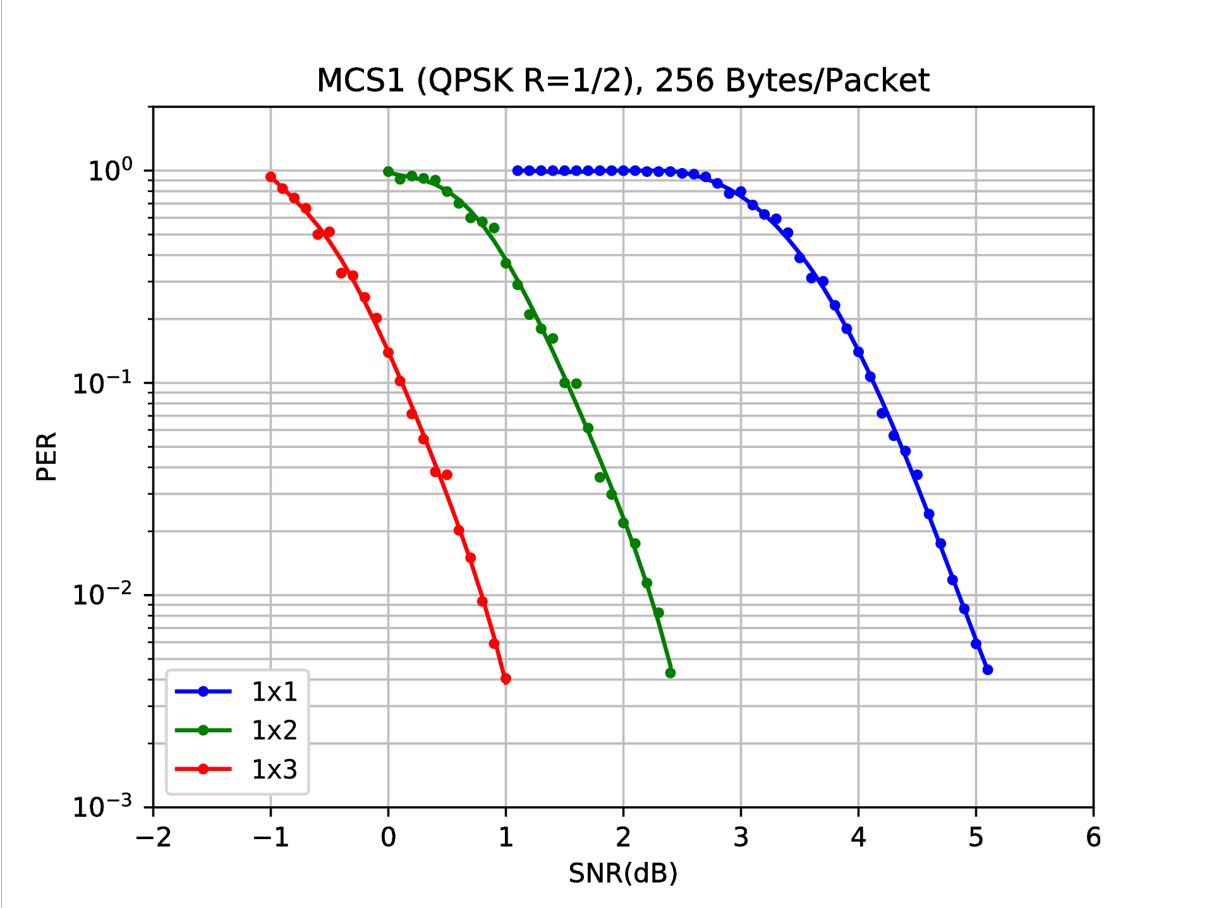

*Figure 8: Receiver performance for various antenna configurations*

TABLE 1

Link budget template for Indoor Hotspot-eMBB

| Item | Downlink | Uplink |
| --- | --- | --- |
| System configuration | | |
| Carrier frequency (GHz) | 2 | 2 |
| BS antenna heights (m) | 3 | 3 |
| UE antenna heights (m) | 1.5 | 1.5 |
| Cell area reliability(1) (%) (Please specify how it is calculated.) |  |  |
| Transmission bit rate for control channel (bit/s) | *1248000* | *1248000* |
| Transmission bit rate for data channel (bit/s) | *1248000* | *1248000* |
| Target packet error ratio for the required SNR in item (19a) for control channel | *0.01* | *0.01* |
| Target packet error ratio for the required SNR in item (19b) for data channel | *0.01* | *0.01* |
| Spectral efficiency(2) (bit/s/Hz) | *1.4* | *1.4* |
| Pathloss model(3) (select from LOS or NLOS) | *NLOS* | *NLOS* |
| UE speed (km/h) | *0* | *0* |
| Feeder loss (dB) | *0* | *0* |
| Transmitter | | |
| (1) Number of transmit antennas (The number shall be within the indicated range in § 8.4 of Report ITU-R M.2412-0) | *1* | *1* |
| (2) Maximal transmit power per antenna (dBm) | *24* | *24* |
| (3) Total transmit power = function of (1) and (2) (dBm)  (The value shall not exceed the indicated value in § 8.4 of Report ITU-R M.2412-0) | *24* | *24* |

TABLE 1 (*continued*)

| Item | Downlink | Uplink |
| --- | --- | --- |
| (4) Transmitter antenna gain (dBi) | *8* | *0* |
| (5) Transmitter array gain (depends on transmitter array configurations and technologies such as adaptive beam forming, CDD (cyclic delay diversity), etc.) (dB) | *0* | *0* |
| (6) Control channel power boosting gain (dB) | *0* | *0* |
| (7) Data channel power loss due to pilot/control boosting (dB) | *0* | *0* |
| (8) Cable, connector, combiner, body losses, etc. (enumerate sources) (dB) (feeder loss must be included for and only for downlink) | *1* | *2* |
| (9a) Control channel e.i.r.p. = (3) + (4) + (5) + (6) – (8) dBm | *31* | *22* |
| (9b) Data channel e.i.r.p. = (3) + (4) + (5) – (7) – (8) dBm | *31* | *22* |
| Receiver | | |
| (10) Number of receive antennas (The number shall be within the indicated range in § 8.4 of Report ITU-R M.2412-0) | *2* | *2* |
| (11) Receiver antenna gain (dBi) | *0* | *8* |
| (12) Cable, connector, combiner, body losses, etc. (enumerate sources) (dB) (feeder loss must be included for and only for uplink) | *2* | *1* |
| (13) Receiver noise figure (dB) | 7 | 5 |
| (14) Thermal noise density (dBm/Hz) | −174 | −174 |
| (15) Receiver interference density (dBm/Hz) | *-166* | *-166* |
| (16) Total noise plus interference density  = 10 log (10^(((13) + (14))/10) + 10^((15)/10)) dBm/Hz | *-163* | *-164* |
| (17) Occupied channel bandwidth (for meeting the requirements of the traffic type) (Hz) | *1.5 x 106* | *1.5 x 106* |
| (18) Effective noise power = (16) + 10 log((17)) dBm | *-102* | *-102* |
| (19a) Required SNR for the control channel (dB) | *1.7* | *1.7* |
| (19b) Required SNR for the data channel (dB) | *1.7* | *1.7* |
| (20) Receiver implementation margin (dB) | *4* | *2* |
| (21a) H-ARQ gain for control channel (dB) | *0* | *0* |
| (21b) H-ARQ gain for data channel (dB) | *0* | *0* |
| (22a) Receiver sensitivity for control channel  = (18) + (19a) + (20) – (21a) dBm | *-96* | *-99* |
| (22b) Receiver sensitivity for data channel  = (18) + (19b) + (20) – (21b) dBm | *-96* | *-99* |
| (23a) Hardware link budget for control channel  = (9a) + (11) − (22a) dB | *127* | *129* |

TABLE 1 (*end*)

| Item | Downlink | Uplink |
| --- | --- | --- |
| (23b) Hardware link budget for data channel  = (9b) + (11) − (22b) dB | *127* | *129* |
| Calculation of available pathloss | | |
| (24) Lognormal shadow fading std deviation (dB) | *4* | *4* |
| (25) Shadow fading margin (function of the cell area reliability and (24)) (dB) | *8* | *8* |
| (26) BS selection/macro-diversity gain (dB) | *0* | *0* |
| (27) Penetration margin (dB) | *0* | *0* |
| (28) Other gains (dB) (if any please specify) | *0* | *0* |
| (29a) Available path loss for control channel  = (23a) – (25) + (26) – (27) + (28) – (12) dB | *117* | *120* |
| (29b) Available path loss for data channel  = (23b) – (25) + (26) – (27) + (28) – (12) dB | *117* | *120* |
| Range/coverage efficiency calculation | | |
| (30a) Maximum range for control channel (based on (29a) and according to the system configuration section of the link budget) (m) | *198* | *229* |
| (30b) Maximum range for data channel (based on (29b) and according to the system configuration section of the link budget) (m) | *198* | *229* |
| (31a) Coverage Area for control channel = (π (30a)2) (m2/site) | *122761* | *164900* |
| (31b) Coverage Area for data channel = (π (30b)2) (m2/site) | *122761* | *164900* |
| (1) Cell area reliability is defined as the percentage of the cell area over which coverage can be guaranteed. It is obtained from the cell edge reliability, shadow fading standard deviation and the path loss exponent. The latter two values are used to calculate a fade margin. Macro diversity gain may be considered explicitly and improve the system margin or implicitly by reducing the fade margin.  (2) The spectral efficiency of the chosen modulation scheme.  (3) The pathloss models are summarized in § 9.1 of Report ITU-R M.2412-0. | | |

*5.2.3.3.2 Urban Macro-mMTC environment for DECT-2020 NR*

*For the purpose of TABLE 4 calculations, the system configuration is according to parameters shown in the table below.*

*Table 11: System configuration parameters for Urban Macro-mMTC*

|  |  |  |
| --- | --- | --- |
| ***Parameter*** | ***Value*** | ***Description*** |
| *Modulation* | *QPSK* | *OFDM subcarrier modulation* |
| *R* | *3/4* | *Rate of binary convolutional code* |
| *W* | *1.728* | *Transmission bandwidth (MHz)* |
| *NSS* | *1* | *Number of spatial streams* |
| *NPL* | *32* | *Payload size (bytes)* |
| *ACR* | *6* | *Adjacent channel rejection (dB)* |

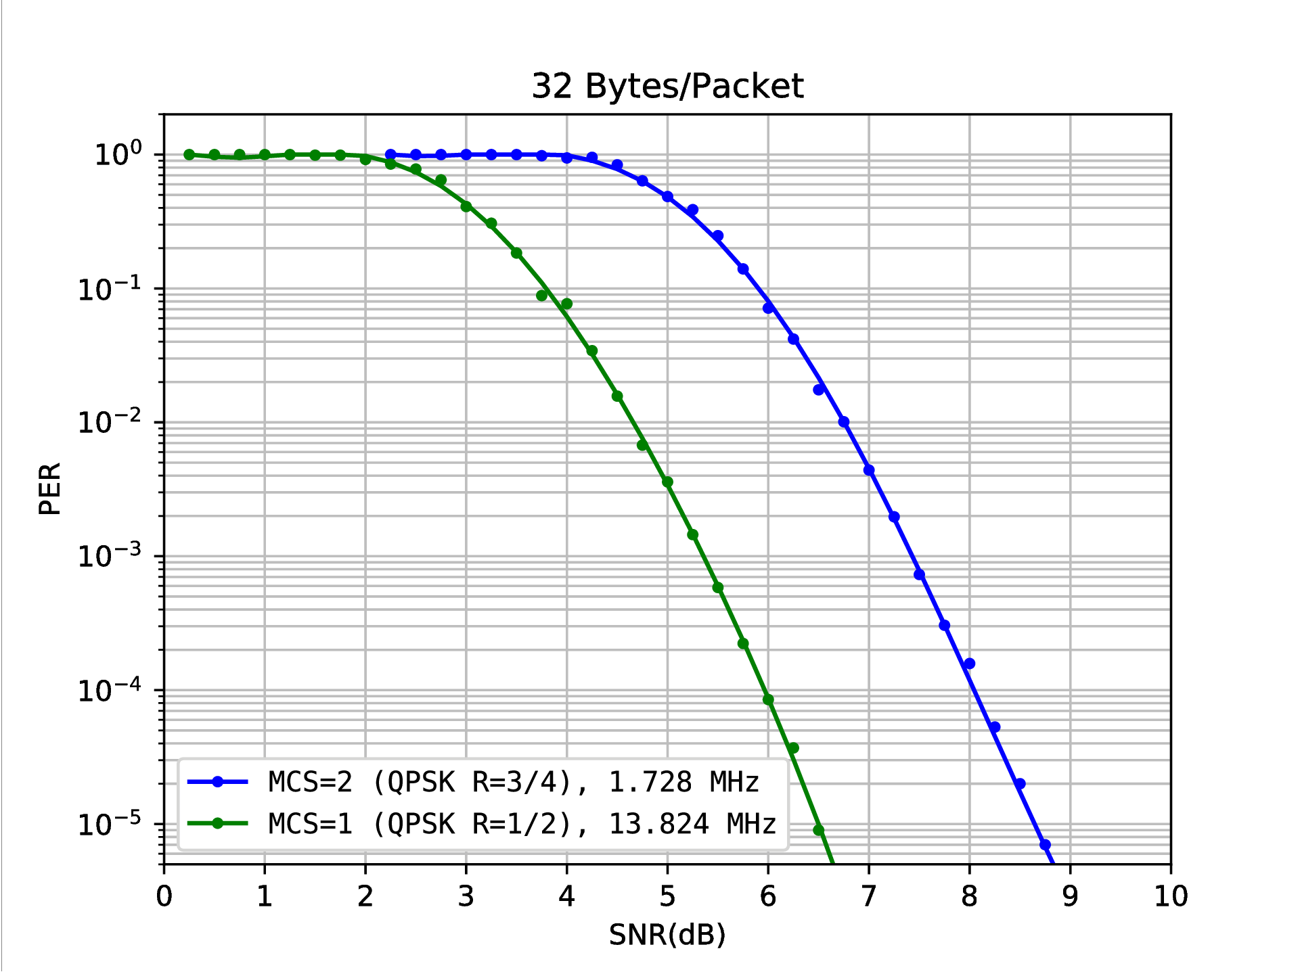

*Figure 9: Receiver performance for mMTC 1x1 configurations*

TABLE 4

Link budget template for Urban Macro–mMTC (NLOS)

| Item | Downlink | Uplink |
| --- | --- | --- |
| System configuration | | |
| Carrier frequency (GHz) | 0.7 | 0.7 |
| BS antenna heights (m) | 25 | 25 |
| UE antenna heights (m) | 1.5 | 1.5 |
| Cell area reliability(1) (%) (Please specify how it is calculated.) | *100%* | *100%* |
| Transmission bit rate for control channel (bit/s) | *1872000* | *1872000* |
| Transmission bit rate for data channel (bit/s) | *1872000* | *1872000* |
| Target packet error ratio for the required SNR in item (19a) for control channel | *10-5* | *10-5* |
| Target packet error ratio for the required SNR in item (19b) for data channel | *10-5* | *10-5* |
| Spectral efficiency(2) (bit/s/Hz) | *1.4* | *1.4* |
| Pathloss model(3) (Select from LOS, NLOS or O-to-I) | *NLOS* | *NLOS* |
| UE speed (km/h) | *0* | *0* |
| Feeder loss (dB) | *0* | *0* |
| Transmitter | | |
| (1) Number of transmit antennas (The number shall be within the indicated range in § 8.4 of Report ITU-R M.2412-0) | *1* | *1* |
| (2) Maximal transmit power per antenna (dBm) | *38* | *23* |
| (3) Total transmit power = function of (1) and (2) (dBm)  (The value shall not exceed the indicated value in § 8.4 of Report ITU-R M.2412-0) | *38* | *23* |
| (4) Transmitter antenna gain (dBi) | *8* | *0* |
| (5) Transmitter array gain (depends on transmitter array configurations and technologies such as adaptive beam forming, CDD (Cyclic delay diversity), etc.) (dB) | *0* | *0* |
| (6) Control channel power boosting gain (dB) | *0* | *0* |
| (7) Data channel power loss due to pilot/control boosting (dB) | *0* | *0* |
| (8) Cable, connector, combiner, body losses, etc. (enumerate sources) (dB) (feeder loss must be included for and only for downlink) | *1* | *2* |
| (9a) Control channel e.i.r.p. = (3) + (4) + (5) + (6) – (8) dBm | *45* | *21* |
| (9b) Data channel e.i.r.p. = (3) + (4) + (5) – (7) – (8) dBm | *45* | *21* |
| Receiver | | |
| (10) Number of receive antennas (The number shall be within the indicated range in § 8.4 of Report ITU-R M.2412-0) | *2* | *2* |
| (11) Receiver antenna gain (dBi) | *0* | *8* |
| (12) Cable, connector, combiner, body losses, etc. (enumerate sources) (dB) (feeder loss must be included for and only for uplink) | *2* | *1* |

TABLE 4 (*continued*)

| Item | Downlink | Uplink |
| --- | --- | --- |
| (13) Receiver noise figure (dB) | 7 | 5 |
| (14) Thermal noise density (dBm/Hz) | −174 | −174 |
| (15) Receiver interference density (dBm/Hz) | *-170* | *-170* |
| (16) Total noise plus interference density  = 10 log (10^(((13)+(14))/10) + 10^((15)/10)) dBm/Hz | *-165* | *-166* |
| (17) Occupied channel bandwidth (for meeting the requirements of the traffic type) (Hz) | *1.5 x 106* | *1.5 x 106* |
| (18) Effective noise power = (16) + 10 log((17)) dBm | *-103* | *-105* |
| (19a) Required SNR for the control channel (dB) | *5.4* | *5.4* |
| (19b) Required SNR for the data channel (dB) | *5.4* | *5.4* |
| (20) Receiver implementation margin (dB) | *4* | *2* |
| (21a) H-ARQ gain for control channel (dB) | *0* | *0* |
| (21b) H-ARQ gain for data channel (dB) | *0* | *0* |
| (22a) Receiver sensitivity for control channel  = (18) + (19a) + (20) – (21a) dBm | *-94* | *-97* |
| (22b) Receiver sensitivity for data channel  = (18) + (19b) + (20) – (21b) dBm | *-94* | *-97* |
| (23a) Hardware link budget for control channel  = (9a) + (11) - (22a) dB | *139* | *126* |
| (23b) Hardware link budget for data channel  = (9b) + (11) - (22b) dB | *139* | *126* |
| Calculation of available pathloss | | |
| (24) Lognormal shadow fading std deviation (dB) | *6* | *6* | |
| (25) Shadow fading margin (function of the cell area reliability and (24)) (dB) | *22.2* | *22.2* | |
| (26) BS selection/macro-diversity gain (dB) | *0* | *0* | |
| (27) Penetration margin (dB) | *0* | *0* | |
| (28) Other gains (dB) (if any please specify) | *0* | *0* | |
| (29a) Available path loss for control channel  = (23a) – (25) + (26) – (27) + (28) – (12) dB | *115* | *103* | |
| (29b) Available path loss for data channel  = (23b) – (25) + (26) – (27) + (28) – (12) dB | *115* | *103* | |
| Range/coverage efficiency calculation | | | |
| (30a) Maximum range for control channel (based on (29a) and according to the system configuration section of the link budget) (m) | *480* | *234* | |
| (30b) Maximum range for data channel (based on (29b) and according to the system configuration section of the link budget) (m) | *480* | *234* | |

TABLE 4 (*end*)

| Item | Downlink | Uplink |
| --- | --- | --- |
| (31a) Coverage Area for control channel = (π (30a)2) (m2/site) | *723030* | *172723* |
| (31b) Coverage Area for data channel = (π (30b)2) (m2/site) | *723030* | *172723* |
|  | | |
| (1) Cell area reliability is defined as the percentage of the cell area over which coverage can be guaranteed. It is obtained from the cell edge reliability, shadow fading standard deviation and the path loss exponent. The latter two values are used to calculate a fade margin. Macro diversity gain may be considered explicitly and improve the system margin or implicitly by reducing the fade margin.  (2) The spectral efficiency of the chosen modulation scheme.  (3) The pathloss models are summarized in § 9.1 of Report ITU-R M.2412-0. | | |

TABLE 4

Link budget template for Urban Macro–mMTC (LOS)

| Item | Downlink | Uplink |
| --- | --- | --- |
| System configuration | | |
| Carrier frequency (GHz) | 0.7 | 0.7 |
| BS antenna heights (m) | 25 | 25 |
| UE antenna heights (m) | 1.5 | 1.5 |
| Cell area reliability(1) (%) (Please specify how it is calculated.) | *100%* | *100%* |
| Transmission bit rate for control channel (bit/s) | *1872000* | *1872000* |
| Transmission bit rate for data channel (bit/s) | *1872000* | *1872000* |
| Target packet error ratio for the required SNR in item (19a) for control channel | *10-5* | *10-5* |
| Target packet error ratio for the required SNR in item (19b) for data channel | *10-5* | *10-5* |
| Spectral efficiency(2) (bit/s/Hz) | *1.4* | *1.4* |
| Pathloss model(3) (Select from LOS, NLOS or O-to-I) | *LOS* | *LOS* |
| UE speed (km/h) | *0* | *0* |
| Feeder loss (dB) | *0* | *0* |
| Transmitter | | |
| (1) Number of transmit antennas (The number shall be within the indicated range in § 8.4 of Report ITU-R M.2412-0) | *1* | *1* |
| (2) Maximal transmit power per antenna (dBm) | *38* | *23* |
| (3) Total transmit power = function of (1) and (2) (dBm)  (The value shall not exceed the indicated value in § 8.4 of Report ITU-R M.2412-0) | *38* | *23* |
| (4) Transmitter antenna gain (dBi) | *8* | *0* |
| (5) Transmitter array gain (depends on transmitter array configurations and technologies such as adaptive beam forming, CDD (Cyclic delay diversity), etc.) (dB) | *0* | *0* |
| (6) Control channel power boosting gain (dB) | *0* | *0* |
| (7) Data channel power loss due to pilot/control boosting (dB) | *0* | *0* |
| (8) Cable, connector, combiner, body losses, etc. (enumerate sources) (dB) (feeder loss must be included for and only for downlink) | *1* | *2* |
| (9a) Control channel e.i.r.p. = (3) + (4) + (5) + (6) – (8) dBm | *45* | *21* |
| (9b) Data channel e.i.r.p. = (3) + (4) + (5) – (7) – (8) dBm | *45* | *21* |
| Receiver | | |
| (10) Number of receive antennas (The number shall be within the indicated range in § 8.4 of Report ITU-R M.2412-0) | *2* | *2* |
| (11) Receiver antenna gain (dBi) | *0* | *8* |
| (12) Cable, connector, combiner, body losses, etc. (enumerate sources) (dB) (feeder loss must be included for and only for uplink) | *2* | *1* |

TABLE 4 (*continued*)

| Item | Downlink | Uplink |
| --- | --- | --- |
| (13) Receiver noise figure (dB) | 7 | 5 |
| (14) Thermal noise density (dBm/Hz) | −174 | −174 |
| (15) Receiver interference density (dBm/Hz) | *-170* | *-170* |
| (16) Total noise plus interference density  = 10 log (10^(((13)+(14))/10) + 10^((15)/10)) dBm/Hz | *-165* | *-166* |
| (17) Occupied channel bandwidth (for meeting the requirements of the traffic type) (Hz) | *1.5 x 106* | *1.5 x 106* |
| (18) Effective noise power = (16) + 10 log((17)) dBm | *-103* | *-105* |
| (19a) Required SNR for the control channel (dB) | *5.4* | *5.4* |
| (19b) Required SNR for the data channel (dB) | *5.4* | *5.4* |
| (20) Receiver implementation margin (dB) | *4* | *2* |
| (21a) H-ARQ gain for control channel (dB) | *0* | *0* |
| (21b) H-ARQ gain for data channel (dB) | *0* | *0* |
| (22a) Receiver sensitivity for control channel  = (18) + (19a) + (20) – (21a) dBm | *-94* | *-97* |
| (22b) Receiver sensitivity for data channel  = (18) + (19b) + (20) – (21b) dBm | *-94* | *-97* |
| (23a) Hardware link budget for control channel  = (9a) + (11) - (22a) dB | *139* | *126* |
| (23b) Hardware link budget for data channel  = (9b) + (11) - (22b) dB | *139* | *126* |
| Calculation of available pathloss | | |
| (24) Lognormal shadow fading std deviation (dB) | *4* | *4* | |
| (25) Shadow fading margin (function of the cell area reliability and (24)) (dB) | *13.8* | *13.8* | |
| (26) BS selection/macro-diversity gain (dB) | *0* | *0* | |
| (27) Penetration margin (dB) | *0* | *0* | |
| (28) Other gains (dB) (if any please specify) | *0* | *0* | |
| (29a) Available path loss for control channel  = (23a) – (25) + (26) – (27) + (28) – (12) dB | *124* | *111* | |
| (29b) Available path loss for data channel  = (23b) – (25) + (26) – (27) + (28) – (12) dB | *124* | *111* | |
| Range/coverage efficiency calculation | | | |
| (30a) Maximum range for control channel (based on (29a) and according to the system configuration section of the link budget) (m) | *2479* | *1232* | |
| (30b) Maximum range for data channel (based on (29b) and according to the system configuration section of the link budget) (m) | *2479* | *1232* | |

TABLE 4 (*end*)

| Item | Downlink | Uplink |
| --- | --- | --- |
| (31a) Coverage Area for control channel = (π (30a)2) (m2/site) | *19299520* | *4764761* |
| (31b) Coverage Area for data channel = (π (30b)2) (m2/site) | *19299520* | *4764761* |
|  | | |
| (1) Cell area reliability is defined as the percentage of the cell area over which coverage can be guaranteed. It is obtained from the cell edge reliability, shadow fading standard deviation and the path loss exponent. The latter two values are used to calculate a fade margin. Macro diversity gain may be considered explicitly and improve the system margin or implicitly by reducing the fade margin.  (2) The spectral efficiency of the chosen modulation scheme.  (3) The pathloss models are summarized in § 9.1 of Report ITU-R M.2412-0. | | |

*5.2.3.3.3 Urban Macro-URLLC environment for DECT-2020 NR*

*For the purpose of TABLE 5 calculations, the system configuration is according to parameters shown in the table below.*

*Table 12: System configuration parameters for Urban Macro-URLLC*

|  |  |  |
| --- | --- | --- |
| ***Parameter*** | ***Value*** | ***Description*** |
| *Modulation* | *QPSK* | *OFDM subcarrier modulation* |
| *R* | *3/4* | *Rate of binary convolutional code* |
| *W* | *1.728* | *Transmission bandwidth (MHz)* |
| *NSS* | *1* | *Number of spatial streams* |
| *NPL* | *32* | *Payload size (bytes)* |
| *ACR* | *6* | *Adjacent channel rejection (dB)* |



*Figure 10: Receiver performance for URLLC 1x1 configurations*

TABLE 5

Link budget template for Urban Macro–URLLC (NLOS)

| Item | Downlink | Uplink |
| --- | --- | --- |
| System configuration | | |
| Carrier frequency (GHz) | 0.7 | 0.7 |
| BS antenna heights (m) | 25 | 25 |
| UE antenna heights (m) | 1.5 | 1.5 |
| Cell area reliability(1) (%) (Please specify how it is calculated.) | *95%* | *95%* |
| Transmission bit rate for control channel (bit/s) | *1872000* | *1872000* |
| Transmission bit rate for data channel (bit/s) | *1872000* | *1872000* |
| Target packet error ratio for the required SNR in item (19a) for control channel | *10-5* | *10-5* |
| Target packet error ratio for the required SNR in item (19b) for data channel | *10-5* | *10-5* |
| Spectral efficiency(2) (bit/s/Hz) | *1.4* | *1.4* |
| Pathloss model(3) (Select from LOS, NLOS or O-to-I) | *NLOS* | *NLOS* |
| UE speed (km/h) | *0* | *0* |
| Feeder loss (dB) | *0* | *0* |
| Transmitter | | |
| (1) Number of transmit antennas  (The number shall be within the indicated range in § 8.4 of Report ITU‑R M.2412-0) | *20 (5x4 array)* | *1* |
| (2) Maximal transmit power per antenna (dBm) | *36* | *23* |
| (3) Total transmit power = function of (1) and (2) (dBm)  (The value shall not exceed the indicated value in § 8.4 of Report ITU-R M.2412-0) | *49* | *23* |
| (4) Transmitter antenna gain (dBi) | *8* | *0* |
| (5) Transmitter array gain (depends on transmitter array configurations and technologies such as adaptive beam forming, CDD (cyclic delay diversity), etc.) (dB) | *13* | *0* |

TABLE 5 (*continued*)

| Item | Downlink | Uplink |
| --- | --- | --- |
| (6) Control channel power boosting gain (dB) | *0* | *0* |
| (7) Data channel power loss due to pilot/control boosting (dB) | *0* | *0* |
| (8) Cable, connector, combiner, body losses, etc. (enumerate sources) (dB) (Feeder loss must be included for and only for downlink) | *1* | *2* |
| (9a) Control channel e.i.r.p. = (3) + (4) + (5) + (6) - (8) dBm | *69* | *21* |
| (9b) Data channel e.i.r.p. = (3) + (4) + (5) - (7) - (8) dBm | *69* | *21* |
| Receiver | | |
| (10) Number of receive antennas (The number shall be within the indicated range in § 8.4 of Report ITU-R M.2412-0) | *4* | *20* |
| (11) Receiver antenna gain (dBi) | *0* | *8* |
| (11b) Receiver Diversity gain (dB) | *6* | *13* |
| (12) Cable, connector, combiner, body losses, etc. (enumerate sources) (dB) (Feeder loss must be included for and only for uplink) | *2* | *1* |
| (13) Receiver noise figure (dB) | 7 | 5 |
| (14) Thermal noise density (dBm/Hz) | −174 | −174 |
| (15) Receiver interference density (dBm/Hz) | *-170* | *-170* |
| (16) Total noise plus interference density  = 10 log (10^(((13) + (14))/10) + 10^((15)/10)) dBm/Hz | *-165* | *-166* |
| (17) Occupied channel bandwidth (for meeting the requirements of the traffic type) (Hz) | *1.5 x 106* | *1.5 x 106* |
| (18) Effective noise power = (16) + 10 log((17)) dBm | *-103* | *-105* |
| (19a) Required SNR for the control channel (dB) | *8.6* | *8.6* |
| (19b) Required SNR for the data channel (dB) | *8.6* | *8.6* |
| (20) Receiver implementation margin (dB) | *2* | *2* |
| (21a) H-ARQ gain for control channel (dB) | *0* | *0* |
| (21b) H-ARQ gain for data channel (dB) | *0* | *0* |
| (22a) Receiver sensitivity for control channel  = (18) + (19a) + (20) – (21a) dBm | *-93* | *-97* |
| (22b) Receiver sensitivity for data channel  = (18) + (19b) + (20) – (21b) dBm | *-93* | *-97* |
| (23a) Hardware link budget for control channel  = (9a) + (11) +(11b) - (22a) dB | *168* | *136* |
| (23b) Hardware link budget for data channel  = (9b) + (11) +(11b) - (22b) dB | *168* | *136* |
| Calculation of available pathlos | | |
| (24) Lognormal shadow fading std deviation (dB) | *6* | *6* |
| (25) Shadow fading margin (function of the cell area reliability and (24)) (dB) | *22.2* | *22.2* |

TABLE 5 (*end*)

| Item | Downlink | Uplink |
| --- | --- | --- |
| (26) BS selection/macro-diversity gain (dB) | *0* | *0* |
| (27) Penetration margin (dB) | *0* | *0* |
| (28) Other gains (dB) (if any please specify) | *0* | *0* |
| (29a) Available path loss for control channel  = (23a) – (25) + (26) – (27) + (28) – (12) dB | *144* | *113* |
| (29b) Available path loss for data channel  = (23b) – (25) + (26) – (27) + (28) – (12) dB | *144* | *113* |
| Range/coverage efficiency calculation | | |
| (30a) Maximum range for control channel (based on (29a) and according to the system configuration section of the link budget) (m) | *2565* | *418* |
| (30b) Maximum range for data channel (based on (29b) and according to the system configuration section of the link budget) (m) | *2565* | *418* |
| (31a) Coverage Area for control channel = (π (30a)2) (m2/site) | *20673966* | *548797* |
| (31b) Coverage Area for data channel = (π (30b)2) (m2/site) | *20673966* | *548797* |
|  | | |
| (1) Cell area reliability is defined as the percentage of the cell area over which coverage can be guaranteed. It is obtained from the cell edge reliability, shadow fading standard deviation and the path loss exponent. The latter two values are used to calculate a fade margin. Macro diversity gain may be considered explicitly and improve the system margin or implicitly by reducing the fade margin.  (2) The spectral efficiency of the chosen modulation scheme.  (3) The pathloss models are summarized in § 9.1 of Report ITU-R M.2412-0. | | |

TABLE 5

Link budget template for Urban Macro–URLLC (LOS)

| Item | Downlink | Uplink |
| --- | --- | --- |
| System configuration | | |
| Carrier frequency (GHz) | 0.7 | 0.7 |
| BS antenna heights (m) | 25 | 25 |
| UE antenna heights (m) | 1.5 | 1.5 |
| Cell area reliability(1) (%) (Please specify how it is calculated.) | *95%* | *95%* |
| Transmission bit rate for control channel (bit/s) | *1872000* | *1872000* |
| Transmission bit rate for data channel (bit/s) | *1872000* | *1872000* |
| Target packet error ratio for the required SNR in item (19a) for control channel | *10-5* | *10-5* |
| Target packet error ratio for the required SNR in item (19b) for data channel | *10-5* | *10-5* |
| Spectral efficiency(2) (bit/s/Hz) | *1.4* | *1.4* |
| Pathloss model(3) (Select from LOS, NLOS or O-to-I) | *LOS* | *LOS* |
| UE speed (km/h) | *0* | *0* |
| Feeder loss (dB) | *0* | *0* |
| Transmitter | | |
| (1) Number of transmit antennas  (The number shall be within the indicated range in § 8.4 of Report ITU‑R M.2412-0) | *20* | *1* |
| (2) Maximal transmit power per antenna (dBm) | *36* | *23* |
| (3) Total transmit power = function of (1) and (2) (dBm)  (The value shall not exceed the indicated value in § 8.4 of Report ITU-R M.2412-0) | *49* | *23* |
| (4) Transmitter antenna gain (dBi) | *8* | *0* |
| (5) Transmitter array gain (depends on transmitter array configurations and technologies such as adaptive beam forming, CDD (cyclic delay diversity), etc.) (dB) | *13* | *0* |

TABLE 5 (*continued*)

| Item | Downlink | Uplink |
| --- | --- | --- |
| (6) Control channel power boosting gain (dB) | *0* | *0* |
| (7) Data channel power loss due to pilot/control boosting (dB) | *0* | *0* |
| (8) Cable, connector, combiner, body losses, etc. (enumerate sources) (dB) (Feeder loss must be included for and only for downlink) | *1* | *2* |
| (9a) Control channel e.i.r.p. = (3) + (4) + (5) + (6) - (8) dBm | *69* | *21* |
| (9b) Data channel e.i.r.p. = (3) + (4) + (5) - (7) - (8) dBm | *69* | *21* |
| Receiver | | |
| (10) Number of receive antennas (The number shall be within the indicated range in § 8.4 of Report ITU-R M.2412-0) | *4* | *20* |
| (11) Receiver antenna gain (dBi) | *0* | *8* |
| (11b) Receiver diversity gain (dB) | *6* | *13* |
| (12) Cable, connector, combiner, body losses, etc. (enumerate sources) (dB) (Feeder loss must be included for and only for uplink) | *2* | *1* |
| (13) Receiver noise figure (dB) | 7 | 5 |
| (14) Thermal noise density (dBm/Hz) | −174 | −174 |
| (15) Receiver interference density (dBm/Hz) | *-170* | *-170* |
| (16) Total noise plus interference density  = 10 log (10^(((13) + (14))/10) + 10^((15)/10)) dBm/Hz | *-165* | *-166* |
| (17) Occupied channel bandwidth (for meeting the requirements of the traffic type) (Hz) | *1.5 x 106* | *1.5 x 106* |
| (18) Effective noise power = (16) + 10 log((17)) dBm | *-103* | *-105* |
| (19a) Required SNR for the control channel (dB) | *8.6* | *8.6* |
| (19b) Required SNR for the data channel (dB) | *8.6* | *8.6* |
| (20) Receiver implementation margin (dB) | *2* | *2* |
| (21a) H-ARQ gain for control channel (dB) | *0* | *0* |
| (21b) H-ARQ gain for data channel (dB) | *0* | *0* |
| (22a) Receiver sensitivity for control channel  = (18) + (19a) + (20) – (21a) dBm | *-93* | *-94* |
| (22b) Receiver sensitivity for data channel  = (18) + (19b) + (20) – (21b) dBm | *-93* | *-94* |
| (23a) Hardware link budget for control channel  = (9a) + (11) +(11b) - (22a) dB | *168* | *136* |
| (23b) Hardware link budget for data channel  = (9b) + (11) +(11b) - (22b) dB | *168* | *136* |
| Calculation of available pathloss | | |
| (24) Lognormal shadow fading std deviation (dB) | *4* | *4* |
| (25) Shadow fading margin (function of the cell area reliability and (24)) (dB) | *13.8* | *13.8* |

TABLE 5 (*end*)

| Item | Downlink | Uplink |
| --- | --- | --- |
| (26) BS selection/macro-diversity gain (dB) | *0* | *0* |
| (27) Penetration margin (dB) | *0* | *0* |
| (28) Other gains (dB) (if any please specify) | *0* | *0* |
| (29a) Available path loss for control channel  = (23a) – (25) + (26) – (27) + (28) – (12) dB | *152* | *121* |
| (29b) Available path loss for data channel  = (23b) – (25) + (26) – (27) + (28) – (12) dB | *152* | *121* |
| Range/coverage efficiency calculation | | |
| (30a) Maximum range for control channel (based on (29a) and according to the system configuration section of the link budget) (m) | *12752* | *2166* |
| (30b) Maximum range for data channel (based on (29b) and according to the system configuration section of the link budget) (m) | *12752* | *2166* |
| (31a) Coverage Area for control channel = (π (30a)2) (m2/site) | *510880857* | *14741990* |
| (31b) Coverage Area for data channel = (π (30b)2) (m2/site) | *510880857* | *14741990* |
|  | | |
| (1) Cell area reliability is defined as the percentage of the cell area over which coverage can be guaranteed. It is obtained from the cell edge reliability, shadow fading standard deviation and the path loss exponent. The latter two values are used to calculate a fade margin. Macro diversity gain may be considered explicitly and improve the system margin or implicitly by reducing the fade margin.  (2) The spectral efficiency of the chosen modulation scheme.  (3) The pathloss models are summarized in § 9.1 of Report ITU-R M.2412-0. | | |

#### 5.2.4.1 Compliance template for services[[1]](#footnote-1)

|  |  |  |
| --- | --- | --- |
|  | Service capability requirements | Evaluator’s comments |
| **5.2.4.1.1** | **Support for wide range of services**  Is the proposal able to support a range of services across different usage scenarios (eMBB, URLLC, and mMTC)?: **🗹YES** / NO  Specify which usage scenarios (eMBB, URLLC, and mMTC) the candidate RIT or candidate SRIT can support.(1) | *The SRIT proposal can support eMBB, URLLC and mMTC usage scenarios.* |
| (1) Refer to the process requirements in IMT-2020/2. | | |

#### 5.2.4.2 Compliance template for spectrum3

|  |  |
| --- | --- |
|  | Spectrum capability requirements |
| **5.2.4.2.1** | **Frequency bands identified for IMT**  Is the proposal able to utilize at least one frequency band identified for IMT in the ITU Radio Regulations?: 🗹 **YES** / ~~NO~~  Specify in which band(s) the candidate RIT or candidate SRIT can be deployed.  ***For DECT-2020 NR component RIT:***  *The candidate RIT is designed to operate over:*   1. *The frequency bands currently allocated to DECT service (1880 MHz – 1900 MHz)* 2. *The frequency bands currently allocated to IMT-2000 FT service (1900 MHz – 1980 MHz and 2010 MHz – 2025 MHz)* 3. *Any other frequency band that may be allocated in the future to the service, including bands above 24.25 GHz*   *In particular license exempt frequencies at the 5 GHz band have been considered as possible.*  ***For 3GPP-NR component RIT:***  *Same as in the „3GPP 5G CANDIDATE FOR INCLUSION IN IMT-2020: SUBMISSION 2 FOR IMT-2020 (RIT)“ package.* |
| **5.2.4.2.2** | **Higher Frequency range/band(s)**  Is the proposal able to utilize the higher frequency range/band(s) above 24.25 GHz?: 🗹**YES** / NO  Specify in which band(s) the candidate RIT or candidate SRIT can be deployed.  NOTE 1 – In the case of the candidate SRIT, at least one of the component RITs need to fulfil this requirement.  ***For DECT-2020 NR component RIT:***  *Any other frequency band that may be allocated in the future to the service, including bands above 24.25 GHz.*  ***For 3GPP-NR component RIT:***  *Same as in the „3GPP 5G CANDIDATE FOR INCLUSION IN IMT-2020: SUBMISSION 2 FOR IMT-2020 (RIT)“ package.* |

#### 5.2.4.3 Compliance template for technical performance for DECT-2020 NR3

| Minimum technical performance requirements item (5.2.4.3.x), units, and Report ITU-R M.2410-0 section reference(1) | Category | | | Required value | Value(2) | Requirement met? | Comments (3) |
| --- | --- | --- | --- | --- | --- | --- | --- |
| Usage scenario | Test environment | Downlink or uplink |  |  |  |  |
| **5.2.4.3.1** Peak data rate (Gbit/s) *(4.1)* | eMBB | Not applicable | Downlink | 20 | *N/A* | 🗹 Yes  No |  |
| Uplink | 10 | *N/A* | 🗹 Yes  No |
| **5.2.4.3.2** Peak spectral efficiency (bit/s/Hz) *(4.2)* | eMBB | Not applicable | Downlink | 30 | *N/A* | 🗹 Yes  No |  |
| Uplink | 15 | *N/A* | 🗹 Yes  No |
| **5.2.4.3.3** User experienced data rate (Mbit/s) *(4.3)* | eMBB | Dense Urban – eMBB | Downlink | 100 | *N/A* | Yes  No |  |
| Uplink | 50 | *N/A* | Yes  No |
| **5.2.4.3.4** 5th percentile user spectral efficiency (bit/s/Hz) *(4.4)* | eMBB | Indoor Hotspot – eMBB | Downlink | 0.3 | *N/A* | Yes  No |  |
| Uplink | 0.21 | *N/A* | Yes  No |
| eMBB | Dense Urban – eMBB | Downlink | 0.225 | *N/A* | Yes  No |  |
| Uplink | 0.15 | *N/A* | Yes  No |
| eMBB | Rural – eMBB | Downlink | 0.12 | *N/A* | Yes  No |  |
| Uplink | 0.045 | *N/A* | Yes  No |
| **5.2.4.3.5** Average spectral efficiency (bit/s/Hz/ TRxP) *(4.5)* | eMBB | Indoor Hotspot – eMBB | Downlink | 9 | *N/A* | Yes  No |  |
| Uplink | 6.75 | *N/A* | Yes  No |
| eMBB | Dense Urban – eMBB | Downlink | 7.8 | *N/A* | Yes  No |  |
| Uplink | 5.4 | *N/A* | Yes  No |
| eMBB | Rural – eMBB | Downlink | 3.3 | *N/A* | Yes  No |  |
| *N/A* | Yes  No |  |
| Uplink | 1.6 | *N/A* | Yes  No |  |
| *N/A* | Yes  No |  |
| **5.2.4.3.6** Area traffic capacity (Mbit/s/m2) *(4.6)* | eMBB | Indoor-Hotspot – eMBB | Downlink | 10 | *N/A* | Yes  No |  |
| **5.2.4.3.7** User plane latency (ms) *(4.7.1)* | eMBB | Not applicable | Uplink and Downlink | 4 | *N/A* | Yes  No |  |
| URLLC | Not applicable | Uplink and Downlink | 1 | *0.79 ms* | 🗹 Yes  No | See annex B.1 |
| **5.2.4.3.8** Control plane latency (ms) *(4.7.2)* | eMBB | Not applicable | Not applicable | 20 | *N/A* | Yes  No |  |
| URLLC | Not applicable | Not applicable | 20 | *7.832 or 11.832 ms* | 🗹 Yes  No | See annex B.2 |
| **5.2.4.3.9** Connection density (devices/km2) *(4.8)* | mMTC | Urban Macro – mMTC | Uplink | 1 000 000 | *> 1 000 000* | 🗹 Yes  No | See annexA |
| **5.2.4.3.10** Energy efficiency *(4.9)* | eMBB | Not applicable | Not applicable | Capability to support a high sleep ratio and long sleep duration | *N/A* | Yes  No |  |
| **5.2.4.3.11** Reliability *(4.10)* | URLLC | Urban Macro –URLLC | Uplink or Downlink | 1-10−5 success probability of transmitting a layer 2 PDU (protocol data unit) of size 32 bytes within 1 ms in channel quality of coverage edge | *1-10−5* | 🗹 Yes  No | See annexC |
| **5.2.4.3.12** Mobility classes *(4.11)* | eMBB | Indoor Hotspot – eMBB | Uplink | Stationary, Pedestrian | *N/A* | Yes  No |  |
| eMBB | Dense Urban – eMBB | Uplink | Stationary, Pedestrian,  Vehicular (up to 30 km/h) | *N/A* | Yes  No |  |
| eMBB | Rural – eMBB | Uplink | Pedestrian, Vehicular, High speed vehicular | *N/A* | Yes  No |  |
| **5.2.4.3.13**  Mobility Traffic channel link data rates (bit/s/Hz) *(4.11)* | eMBB | Indoor Hotspot – eMBB | Uplink | 1.5 (10 km/h) | *N/A* | Yes  No |  |
| eMBB | Dense Urban – eMBB | Uplink | 1.12 (30 km/h) | *N/A* | Yes  No |  |
| eMBB | Rural – eMBB | Uplink | 0.8 (120 km/h) | *N/A* | Yes  No |  |
| 0.45 (500 km/h) | *N/A* | Yes  No |  |
| **5.2.4.3.14** Mobility interruption time (ms)  *(4.12)* | eMBB and URLLC | Not applicable | Not applicable | 0 | *0* | 🗹 Yes  No | See annexD |
| **5.2.4.3.15** Bandwidth and Scalability *(4.13)* | Not applicable | Not applicable | Not applicable | At least 100 MHz | *108 MHz with subcarrier x4 and FFT =1024* | 🗹 Yes  No |  |
| Up to 1 GHz | *432 MHz per link with subcarrier x16 and FFT =1024*  *3 links = 1.296 GHz* | 🗹 Yes  No |  |
| Support of multiple different bandwidth values(4) | *0.6 – 432 MHz (per layer 1 link)* | 🗹 Yes  No |  |
| (1) As defined in Report ITU-R M.2410-0.  (2) According to the evaluation methodology specified in Report ITU-R M.2412-0.  (3) Proponents should report their selected evaluation methodology of the Connection density, the channel model variant used, and evaluation configuration(s) with their exact values (e.g. antenna element number, bandwidth, etc.) per test environment, and could provide other relevant information as well. For details, refer to Report ITU-R M.2412-0, in particular, § 7.1.3 for the evaluation methodologies, § 8.4 for the evaluation configurations per each test environment, and Annex 1 on the channel model variants.  (4) Refer to § 7.3.1 of Report ITU-R M.2412-0. | | | | | | | |

#### 5.2.4.4 Compliance template for technical performance for 3GPP-NR

*Same as in the „3GPP 5G CANDIDATE FOR INCLUSION IN IMT-2020: SUBMISSION 2 FOR IMT-2020 (RIT)“ package.*

Annex A: mMTC self evaluation details

# A.1 System simulations for mMTC

### A.1.1 Introduction

ITU-R has defined minimum connectivity density for the purpose of evaluation the mMTC scenario.

The connection density is defined as 1 000 000 devices per km2, with each device sending 32 byte packet in every 2 hours. The maximum delay of each packet is 10 seconds, otherwise such packet is considered as “not delivered”. Packet outage i.e. the packet drop ratio to be evaluated is defined as 1 % [1]. With defined scenario, device density, and the traffic model, the requirement is that each sector/cell (our case sink) can receive 10 packets/s.

In the following sections, we present our simulation results with following considerations:

* Link performance is based on QPSK modulation with ¾ coding rate.
* Single 32-byte packet takes full slot (0.416 ms).
* Acknowledgement (ACK) feedback is transmitted in full slot.
* The device processing time is been taken into account, so that the ACK transmission can start 2 ms after reception of the packet, i.e.2 ms is the packet coding delay. After ACK transmission, the device can forward the data to next hop in mesh topology.
* Each device applies the power control and reduce the TX power to the only needed level for the next hop communication.
* Packets maybe also dropped due to extensive number of packets stored in device memory, the limit is set to 50 packets, (1.6 KB). However, this is an implementation related aspect, but provides us some additional indication if such issues arise.

We present following simulation results: The results based on ITU-R evaluation configuration and in addition the results based on DECT configuration (operating at 1900 MHz with a BS antenna hight of 5 m). In both results the evaluation has been done as following:

1. mMTC system performance with using single 1.728 MHz channel, i.e. all devices are operating in same radio channel sharing it in time domain.
2. mMTC system performance using three 1.728 MHz channels, where each device is able to select its operating channel based on neighbour information.
3. Number of devices is kept unchanged, i.e. fulfilling the ITU-R requirement and the packet arrival intensity is increased until the 1 percent packet error rate, including 10 second packet delay limit, is met.

## A.1.2 Results

### Out of coverage probability

#### Results based on ITU-R configuration

Figure 11 below presents the out of coverage probability of the devices in star topology (right) and in mesh topology (left) in a given environment with ITU-R WP5D parameters. These results are with 25m antenna height and 700 MHz operating band, whereas the maximum TX power is 23 dBm and simple antenna structures are assumed.

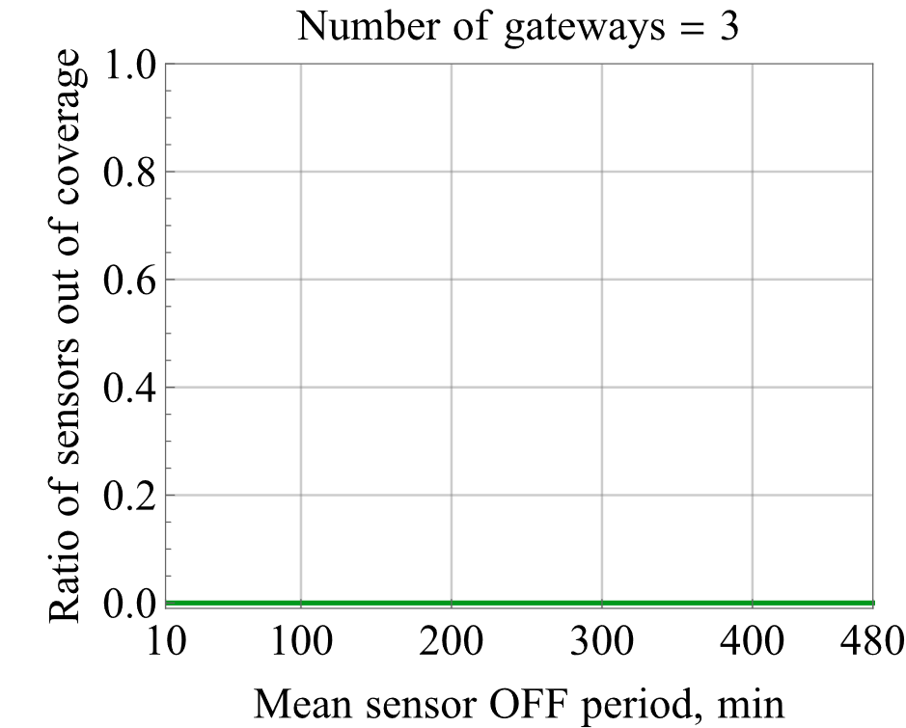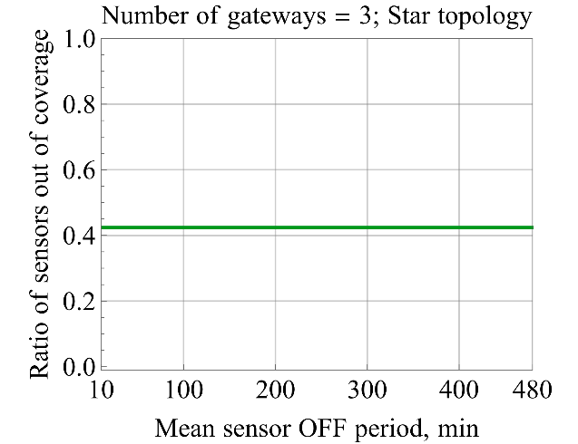

Figure 11: ITU-R configuration (700MHz, 25m antenna height): Out of coverage probability: Left Mesh – right Star (Direct link to Sink allowed)

#### Results based on DECT configuration

Figure 12 below presents the out of coverage probability of the devices in star topology (right) and in mesh topology (left) in a given environment with DECT configuration (1900MHz, 5m antenna height). The figure shows that with current link performance (based on link level simulations and with low antenna gains) the link budget is not sufficient if only direct connection to BTS (sink/gateway) are possible, as more than 50% of devices are out of coverage (devices are uniformly distributed in the area). However, when multi-hop connections with mesh-topology are enabled, every device can connect to the sink and no outage is experienced.

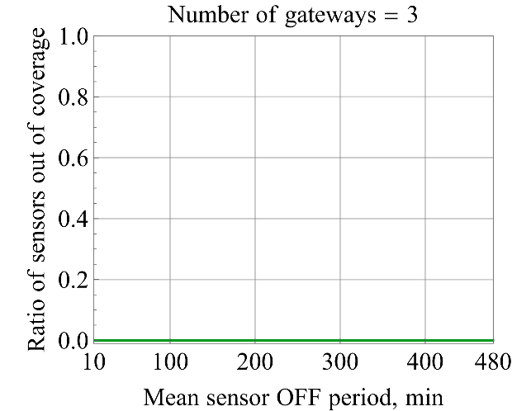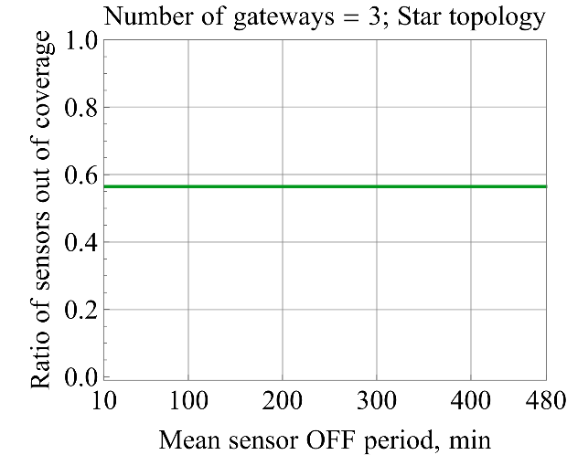

Figure 12: DECT configuration (1900MHz, 5m antenna height): Out of coverage probability: Left Mesh – right Star (Direct link to Sink allowed)

#### Discussion

It should be noted that x-axels in Figure 11 and Figure 12, "Mean sensor OFF period" is the time interval between two packets being generated, i.e. 1 packet every 0.116 h refers 10 min in the figure, and 120 min present 2 hours. The link budget calculations explains the high out of service probability for the star topology case as the maximum NLOS link distance covers roughly 27% of the cell area in DECT configuration. When antenna height is incresed and operating band is changed to 700 MHz, the out of coverage probability is significantly reduced in star topology as bit more than 40% of devices are out of coveage thanks to improved link budget. For mesh topology the out of coverage is 0% for both system parameterisations.

**Conclusion 1: Results for cell area reliablity: 100%, due to multihop mesh for both ITU-R WPD5 and DECT configurations.**

### Packet drop ratio analysis

#### Results based on ITU-R configuration

Figure 13 presents the packet drop ratio (for end-to-end connection) as number of packets per second received by each sector (sink). The green dot shows the ITU-R requirement limit of 10 packets/second, i.e. each 1 000 000 devices per km2 creates one packet in every 2 hours.

For ITU-R scenario using 700 MHz frequency band and 25 m antenna height results are presented in Figure 13 and Table 13 summarizes the obtained results respectively.

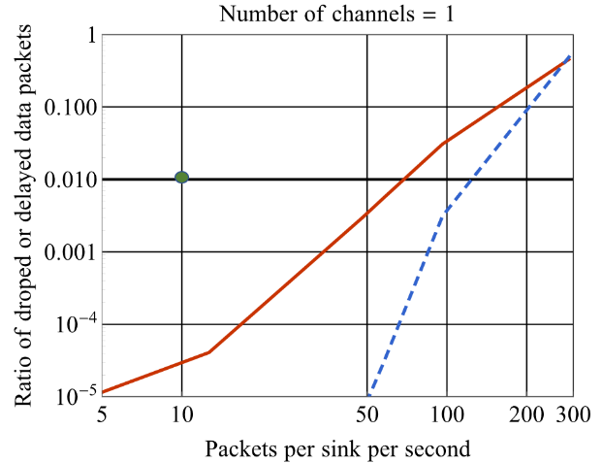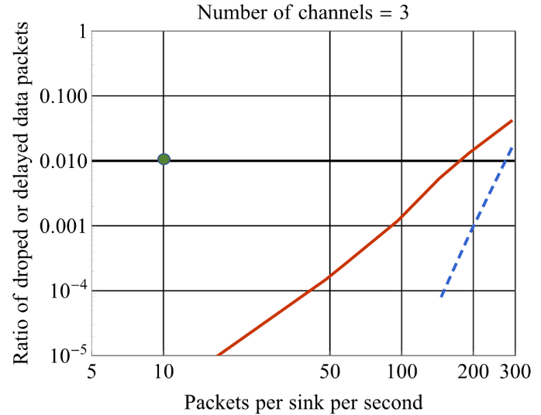

Figure 13: ITU-R configuration: Data Packet Drop ratio (end-to-end) (lost or delayed >10 seconds):   
Left side 1 channel, Right side 3 channels.   
Red line: 3 ARQ attempts, Blue line 8 ARQ attempts per hop (no combining)

Table 13: ITU-R configuration: Number of packets/second/sink or mean packet interval with 1 000 000 devices per km2

|  |  |  |
| --- | --- | --- |
|  | **3 ARQ attempts** | **8 ARQ attempts** |
| **1 channel** | 69 pps or 1 message / 17.4 minutes/device | 124 pps or 1 message / 9.7 minutes/device |
| **3 channels** | 178 pps or 1 message / 6.8 minutes/device | 274 pps or 1 message / 4.4 minutes/device |

#### Results based on DECT configuration

Similarly to previous section, Figure 14 presents the packet drop ratio (for end-to-end connection) as number of packets per second received by each sector (sink). The green dot shows the ITU-R requirement limit of 10 packets/second, i.e. each 1 000 000 devices per km2  creates one packet in every 2 hours.

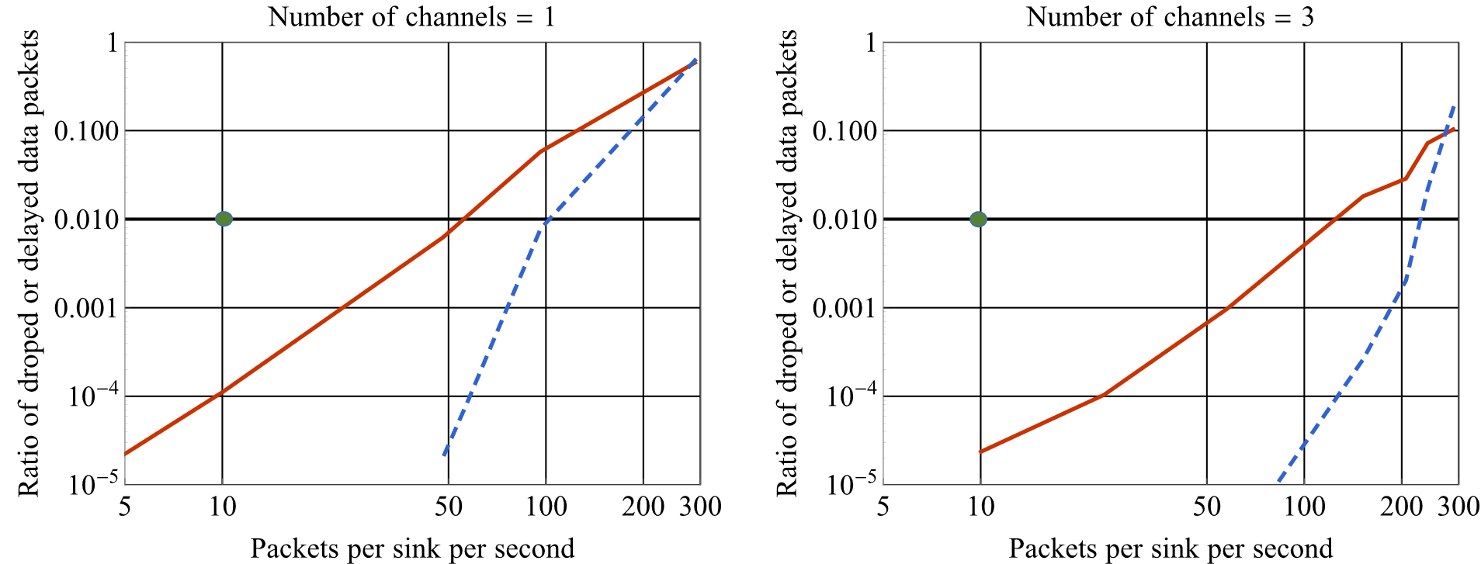

Figure 14: DECT configuration: Data Packet Drop ratio (end-to-end) (lost or delayed >10 seconds):  
 Left side 1 channel, Right side 3 channels.  
 Red line: 3 ARQ attempts, Blue line 8 ARQ attempts per hop (no combining)

Table 14: DECT configuration: Number of packets/second/sink or mean packet interval with 1 000 000 devices per km2

|  |  |  |
| --- | --- | --- |
|  | **3 ARQ attempts** | **8 ARQ attempts** |
| **1 channel** | 56 pps or 1 message / 21.5 minutes/device | 103 pps or 1 message / 11.6 minutes/device |
| **3 channels** | 125 pps or 1 message / 9.6 minutes/device | 228 pps or 1 message / 5.2 minutes/device |

#### Discussion

As in both results the number of devices is kept as in ITU-R requirement, the 100 packets/second operating point means that each device is creating one packet in every 12 minutes instead of 120 minutes. These results indicate that system is able to deliver more frequent information on applications when needed without capacity issues. By using 3 operating channels (less than 5.2MHz of spectrum) with maximum of 3 ARQ attempts the system is able to deliver over 17 times more capacity than ITU-R required when system is deployed on 700 MHz. Indeed, based on results it is clear that changing the transmission band from 1900 MHz to 700 MHz and increasing the BS antenna height from 5m to 25m the system capacity is improved more than 20%.

### 99.9 percentile end to end delay performance

#### Results for ITU-R configuration

Figure 15 shows the results using 700 MHz band and 25 m antenna height for the end to end delay of 99.9 percentile, i.e. at this point only 0.1% of packet are dropped due to delay. Again, the green dot represents the ITU-R requirement of 10 second delay limit. Notable, when using 3 operating channels at 700MHz even 300 packets per second is not sufficient to exceed 10 second delay limit.

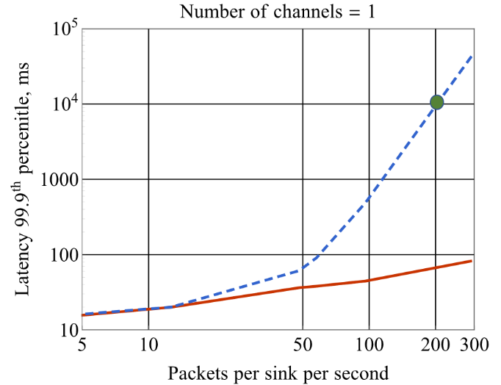 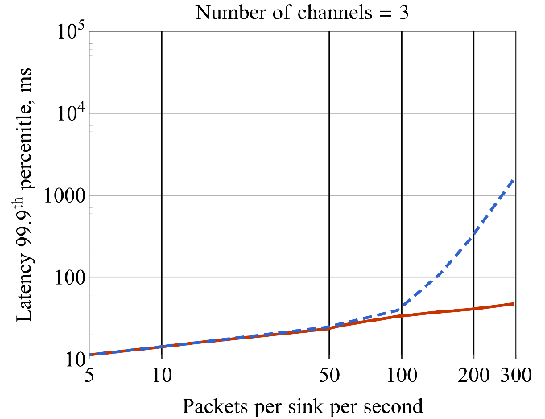

Figure 15: End to End Packet Delay of 99.9th percentile  
Left side 1 channel Right side 3 channels.  
 Red line: 3 ARQ attempts, Blue line 8 ARQ attempts per hop (no combining)

#### Results for DECT configuration

In Figure 16 we show the end to end delay of 99.9 percentile, i.e. at this point only 0.1% of packet are dropped, using the DECT configuration. Again, the green dot represents the ITU-R requirement of 10 second delay limit.

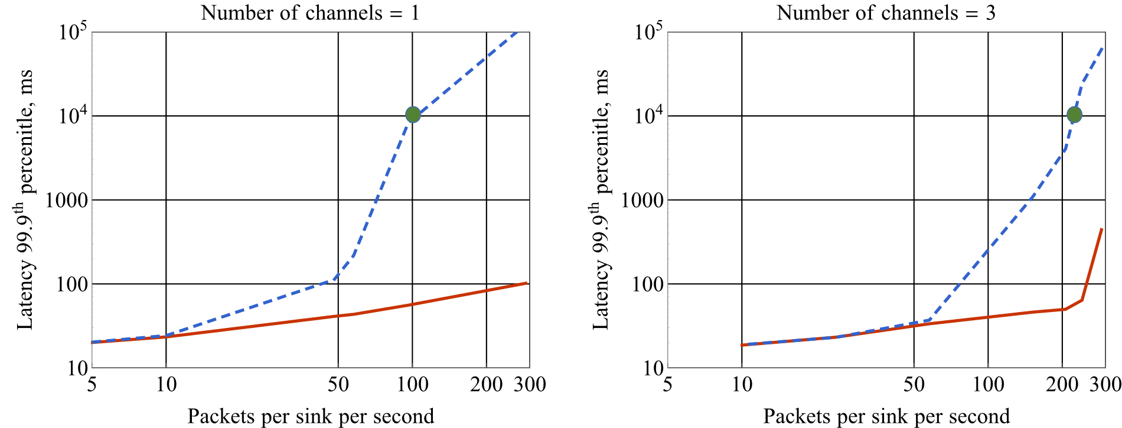

Figure 16: DECT configuration: End to End Packet Delay of 99.9th percentile  
Left side 1 channel Right side 3 channels.  
 Red line: 3 ARQ attempts, Blue line 8 ARQ attempts per hop (no combining)

#### Discussion

It is notable that the end to end delay is never exceeding 10 seconds when only 3 ARQ attempts are allowed per hop when one or multiple channels (3 or more) are used. When high number of re-transmissions is allowed the delay starts to cumulate when the system starts to be overloaded. This overload point is around 105 pps and 222 pps (for 1 channel or 3 channels respectively) for 99.9 percentile performance point for the DECT configuration.

For WP5D configuration as the capacity is increased the delay of 99,9 percentile of the packets is reached at the level of 200 pps with single channel and when 8 re-transmissions is allowed. It is also notable when the system is not in overload situation, the system can provide below 100 ms end to end latency with very high reliability of 10-5.

**Conclusion 2: DECT-2020 using single 1.728 MHz channel can support ITU-R Connection density of 1 000 000 devices per km2 with required data intensity.**

**Conclusion 3: In case of 3 channel used for mMTC system, the capacity is more than doubled compared single channel results.**

**Conclusion 4: Supported traffic intensity per device can be significantly higher as shown in Table 13. With single 1.728 MHz channel the 1 000 000 device density, each device can send packet in every 9.7 minutes. Alternatively, this capacity can be used for increasing the number of devices, when keeping the traffic intensity at ITU-R requirement level, or used for other services.**

**Conclusion 5: When using ITU-R scenario parameters, 700MHz as operating band and 25m as BS antenna height improves the system capacity more than 20% compared with the DECT scenario.**

# Annex B – Additional Information on URLLC scenario

## B.1 U-plane latency evaluation

For low-latency systems, the DECT frame will be configured with alternating down-link / up-link slots. Low-latency transmissions use a high-efficiency packet “full slot” (slot width is 0.416 ms). Transmitter processing delay is 1 OFDM symbol (0.0416 ms). Receiver processing delay is 2 OFDM symbols (0.0832 ms).

Assuming “full-buffer” scenario, where data is always available for transmission (this is normal case for audio streaming or closed-loop control systems), then the U-plane latency is: 0.416 + 0.0416 + 0.0832 = 0.5408 ms.

U-plane latency calculation is identical for up-link and down-link cases.

When HARQ is used, the HARQ round-trip duration is 6 slots in worst case, i.e. 6 × 0.416 = 2.496 ms. If we assume HARQ BLER of 10%, then this will contribute 0.2496 ms to the average U-plane latency, i.e. when HARQ is used the average U-plane latency is: 0.5408 + 0.2496 = 0.7904 ms.

Table 15: U-plane latency

|  |  |  |
| --- | --- | --- |
| Step | Description | Value |
| 1 | Transmitter pre-processing delay | 0.0416 ms |
| 3 | TTI for data packet transmission | 0.416 ms |
| 4 | HARQ retransmission (6 slots round trip, assuming 10% BLER) | 0.2496 ms |
| 5 | Receiver processing delay | 0.0832 ms |
|  | Total one way user plane latency | 0.7904 ms |

## B.2 C-plane latency evaluation

A DECT-2020 PP potentially supports several different “battery efficient” states, e.g. powered-down, hibernating, low-duty cycle, etc. For the purpose of the study of the C-plane latency, the assumption is that the PP is locked to the FP, i.e. periodically receiving the FP’s beacon transmission. In DECT terminology, this is “Idle Locked” state. The end-state is the start of “continuous data transfer”. In DECT terminology, this is “Active Locked” state.

The process of transition from “Idle Locked” to “Active Locked” state requires the PP to send an “Access Request” message on an available Random Access Channel, and then receive an “Access Grant” message from the FP. The allocated resources can then be used at the first availability.

In an un-loaded system, we assume there is availability of Random Access Channels (and no contention with other users) and that there are resources available for the “continuous data transfer”.

Table 16: Signalling delay from non-associated to associated

|  |  |  |
| --- | --- | --- |
| Component | Delay [ms] | Comment |
| Average association request TX resource waiting time | 5 | At least one resource in every 10ms frame. More frequent resources allocation is possible. |
| Association request TX message transmission | 0.4167 | Single slot transmission |
| Association request processing time | 1 or 5 | In DECT-2020 only installation DL slot for association response after 2 slots. When operating in legacy DECT compatible mode the response after 12 slots. |
| Association response TX response | 0.4167 | Single slot association response transmission. |
| Association response processing time | 1 | PP processing response. |
| Total | 7.832 or 11.832 | Total time depending on configuration. DECT-2020 only and DECT compatible. |

Annex C: URLLC self evaluation details

# C.1 Introduction

ITU-R has defined minimum reliability requirement to be 1-10−5 error probability for transmitting a layer 2 PDU (protocol data unit) of 32 bytes within 1 ms time limit and in channel quality at the coverage edge in the Urban Macro-URLLC test environment [1]. In order to meet this delay requirement, single time slot transmission of DECT-2020 system is used.

In addition, ITU-R defines that the evaluation of the reliability is performed as combination of system level simulations and link level simulations as defined in [2].

*"* *Step 1: Run downlink or uplink full buffer system-level simulations of candidate RITs/SRITs using the evaluation parameters of Urban Macro-URLLC test environment see § 8.4.1 below, and collect overall statistics for downlink or uplink SINR values, and construct CDF over these values.*

*Step 2: Use the CDF for the Urban Macro-URLLC test environment to save the respective 5th percentile downlink or uplink SINR value.*

*Step 3: Run corresponding link-level simulations for either NLOS or LOS channel conditions using the associated parameters in the Table 8-3 of this Report, to obtain success probability, which equals to (1-Pe), where Pe is the residual packet error ratio within maximum delay time as a function of SINR taking into account retransmission.*

*Step 4: The proposal fulfils the reliability requirement if at the 5th percentile downlink or uplink SINR value of Step 2 and within the required delay, the success probability derived in Step 3 is larger than or equal to the required success probability. It is sufficient to fulfil the requirement in either downlink or uplink, using either NLOS or LOS channel conditions."*

For the URLLC self evaluation downlink full buffer system level simulation has been used.

# System Parameter

The URLLC system simulations are done in Urban Macro URLLC environment as shown in Figure 17 using either UMA\_A or UMA\_B channel model. The environment assumes high tower, and high transmission power macro-cellular base station network deployment with transmission powers up to 49 dBm for 20MHz bandwidth.

Figure 17: Layout of the environment

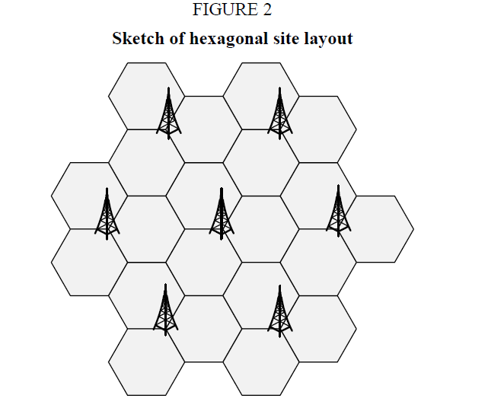

We have considered three URLLC system configuration which we see highly realistic.

* The first one a single 1.728 MHz channel is applied for URLLC service, i.e. system operates in a single frequency network.
* In the second scenario the URLLC system has 3 DECT-2020 channels and frequency reuse is arranged between neighbouring BS’s.
* In the last scenario the URLLC system uses 7 channels out of 10 channels available at the 20 MHz band.

The setup of these three scenarios is presented in Figure 18, including the interfering sources to single reference cell.

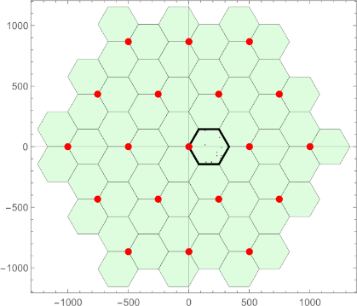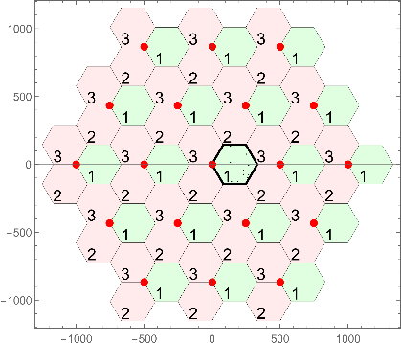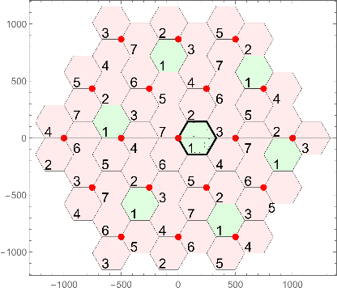

Figure 18: Evaluated URLLC system configuration. Green colour indicates interfering cell to single reference cell. Number indicates the used channel in a given configuration.

Table 17 presents the evaluation configuration parameters, we follow these parameters accurately, providing results with different DL TX power levels and antenna configuration in above system configurations.

Table 17: ITU-R evaluation parameters and DECT URLLC evaluation parameters.

|  |  |  |
| --- | --- | --- |
| **Parameters** | **Rep. ITU-R M.2412-0, Table 5) Urban Macro-URLLC test environments, configuration B** | **DECT-2020 URLLC evaluation** |
| **Baseline evaluation configuration parameters** | | |
| System Architecture | Star with 19 sites, each site has 3 TRxPs (cells). Device connects directly to BS. | Star with 19 sites, each site has 3 TRxPs (cells). Device connects directly to BS. |
| Carrier frequency for evaluation | 700MHz | 700MHz |
| Channel model | Urban Macro | Urban Macro |
| BS antenna height | 25m | 25m |
| Total Tx Power per TRxP in BS/sink | 49dBm for 20MHz | Results provided with 23dBm and 49dBm for 20MHz |
| UE/node power class | 23 | Not applicable as DL only |
| Percentage of high loss and low loss building type | 100% low loss | 100% low loss |
| **Additional parameters for system-level simulation** | | |
| Inter-site distance | 500m | 500m, |
| Number of antenna elements per TxRP | Up to 64 | Results provided with 20, (5x4), 60, (15x4) antenna elements. |
| UE antennas | Up to 4 | 4 |
| Device deployment | 80% indoor, 20% outdoor | 80% indoor, 20% outdoor |
| Inter-site interference modelling | Explicitly modelled | Explicitly modelled |
| BS noise figure | 5 dB | Not applicable – DL only |
| UE noise figure | 7 dB | 7 dB |
| BS/sink antenna element gain | 8 dBi | 8 dBi |
| UE antenna element gain | 0 dBi | 0 dBi |
| Thermal noise level | ‒174 dBm/Hz | -174 dBm/Hz |
| Traffic model | Full buffer | Full buffer |
| Physical layer packet size | Not defined | Not applicable but Single 32 byte can be packet mapped to long pre-ample packet modulated according MCS2 (QPSK ¾), in link simulations. |
| Simulation bandwidth | Up to 100 MHz | Results provided with single, three and 7 non-overlapping channels. Channel Bandwidth 1.728 MHz. |
| UE density | 10 UEs per TRxP | 10 UEs per TRxP |
| UE antenna height | 1.5m | 1.5m |

# System level simulation results

In the following figures we present the simulation results of the obtained SNR and SINR with different number of used of channels, TX power and different BS antenna configurations. The CDF of the SNR represent the signal to noise ratio when no inter cell interference is considered. It can be considered as baseline result showing that system is not noise limited, whereas the SNIR provides the result for ITU-R system evaluation. All figures include two lines, the horizontal line marks the 5th percentile portion of the devices and vertical line marks the 8.6 dB SINR level (Not 0dB level), which corresponds to SINR level for 10-5 BLER in link level simulations. The Table 18 provides the summary of these results.

**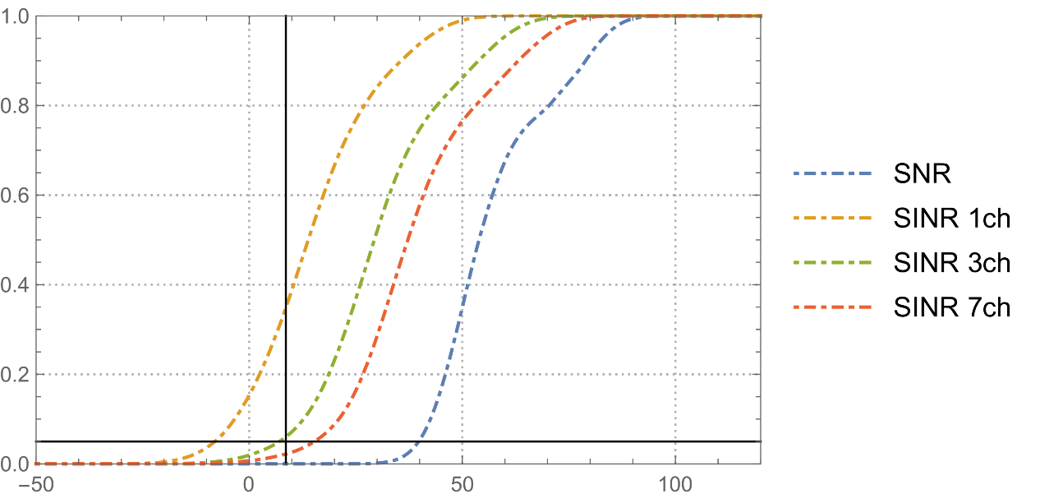**

Figure 19: CDF of the SINR with Tx Power: 23 dBm, BS 5x4 Array

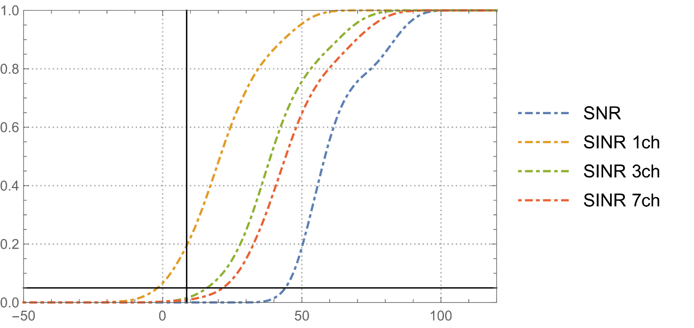

Figure 20: CDF of the SINR with Tx Power: 23 dBm, BS 15x4 Array

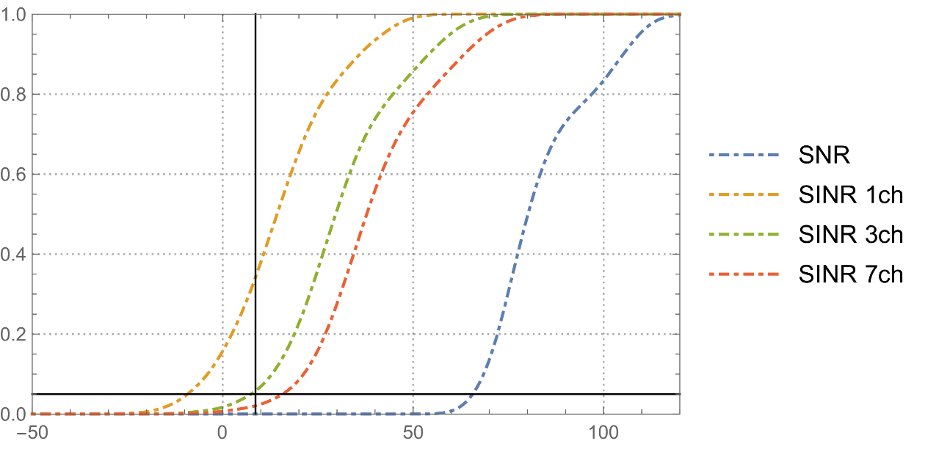

Figure 21: CDF of the SINR with Tx Power: 49 dBm, BS 5x4 Array

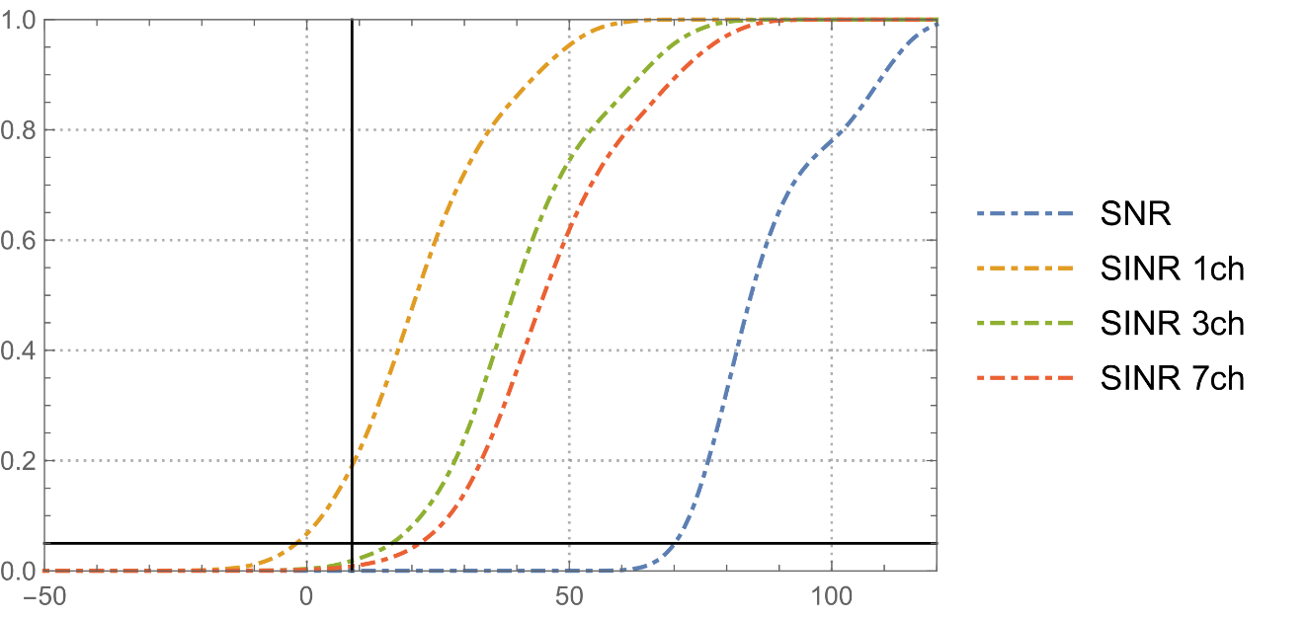

Figure 22: CDF of the SINR with Tx Power: 49 dBm, BS 15x4 Array

Table 18: Obtained SINR values in dB’s at the 5 percentile point of the CDF

|  |  |  |  |  |
| --- | --- | --- | --- | --- |
| Number of used channels | 23dBm Tx power, 5x4 antenna arrow (dB) | 23dBm Tx power, 15x4 antenna arrow (dB) | 49dBm Tx power, 5x4 antenna arrow (dB) | 49dBm Tx power, 15x4 antenna arrow (dB) |
| 1 | -7.7 | -1.5 | -9.0 | -1.7 |
| 3 | 7.2 | 16.1 | 7.6 | 16.6 |
| 7 | 15.5 | 22.0 | 16.2 | 21.6 |

# Link level simulation results

Using DECT-2020 NR downlink/uplink single-stream configuration and BCC coding, the most reliable single-slot, 32 byte payload (as per IMT-2020 requirement for URLLC), long preamble packet corresponds to W = WBC = 1.728 MHz with MCS2 (raw data rate: 1.872 Mbps). Such packet can carry up to 37 bytes over 4 available data field symbols.

From DECT-2020 NR link level simulation results the required SNR for 10−5 PER is approximately 8.6 dB (see Figure 23). It is noted that this value is 1.8 dB better than the SNR value for 1% PER.

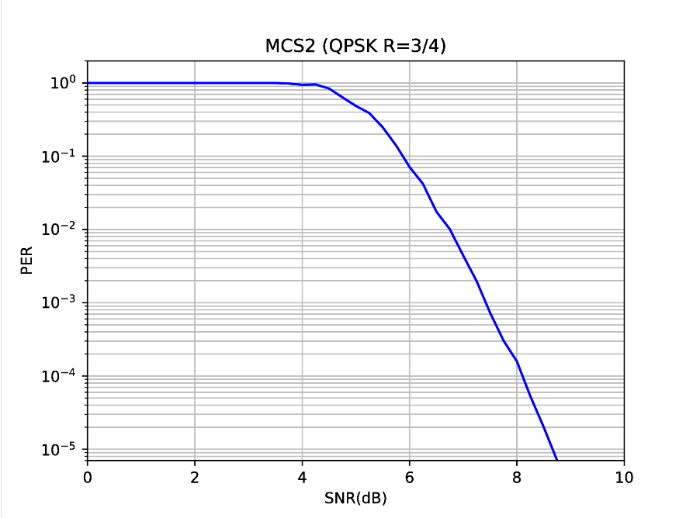

Figure 23: URLLC simulation

# Conclusion

Based on Table 18 results, it can be noted that DECT-2020 can provide clearly higher SINR than 8.6 dB in ITU-R evaluation scenarios when appropriate system configuration is used. The link level simulations the SNIR level was providing the required 10-5 Block error rate. The evaluated configurations that provide much higher SINR were:

* Three or more operating channels with antenna configuration having 15 x 4 antenna elements
* Seven or more operating channels with antenna configuration having 5x4 antenna elements.

Additionally it can be seen that with antenna configuration 5x4 elements, the system less than 1.5 dB away from required SINR level.

From the system and link level simulations a cell area reliability of 95% for URLLC has been obtained.

**Conclusion: DECT-2020 system can meet the URLLC service requirement in ITU-R Macro-URLLC evaluation environment.**

# Annex D – Additional Information on ‘Mobility interruption time’

## D.1 Types of handover

D.1.1 Intra-System handover may be intra-cell or inter cell.

Intra-cell handover may be controlled by either the PP or the FP and triggered when quality on allocated carrier-slot-combinations becomes poor and other free carrier-slot-combinations exist. Detection of free carrier-slot-combinations is based on a spectrum sensing paradigm and takes into account the activity of other uncoordinated systems. Seamless handover is supported. The PP sends a handover-request to the FP on the selected random access channel. If the FP accepts the request, then it indicates the position of the new traffic channel and the data will be switched over. After that the old channel will be released.

Inter-cell handover is generally controlled by the PP and triggered when quality on allocated carrier-slot-combinations becomes poor and another suitable FP is becoming stronger. Seamless handover is supported. The PP sends a handover-request to the new FP on the selected random access channel. If the FP accepts the request, then it indicates the position of the new traffic channel and the data will be switched over. After that the old channel will be released.

D.1.2 Inter-System handover

Inter-System handover is performed in the same way as inter-cell handover. Seamless handover is supported. Both systems should be interconnected by the proper network infrastructure.

## D.2 Interruption time

The handover procedure in DECT is seamless. If there is a need to change the radio link, then the best available new channel is selected to set-up a new link. For a short time the information is transmitted in parallel on the old as well on the new link. After the quality of the transmission on the new link has been confirmed, the old link will be released and the handover procedure has been completed. This seamless handover guarantees, that there is no interruption time for the transmitted user information.

# Annex E – References

1. Report ITU-R M.2410-0 Minimum requirements related to technical performance for IMT-2020 radio interface(s), (11/2017)
2. Report ITU-R M.2412-0 Guidelines for evaluation of radio interface technologies for IMT-2020, (10/2017)

[3] 3GPP TS 23.501 “3rd Generation Partnership Project; Technical Specification Group Services and System Aspects; System Architecture for the 5G System; Stage 2 (Release 16)”

[4] ETSI TR 103 514 “Digital Enhanced Cordless Telecommunications (DECT); DECT-2020 New Radio (NR) interface; Study on Physical (PHY) layer”

1. If a proponent determines that a specific question does not apply, the proponent should indicate that this is the case and provide a rationale for why it does not apply. [↑](#footnote-ref-1)